******The British College**

**KATHMANDU**

**Coursework Submission Coversheet**(individual coursework exclusively)

**Faculty of Arts, Environment and Technology**

77356702

**LBU Student Id:**

**For checking by the student:**

Please ensure all information is complete and correct and attach this form securely to the front of your work before posting it in a coursework collection box.

Award name: BSc (Hons) Computing

Module code: COMP607

Module name: Production Project

Module run:

Coursework title: Breaking the Slience: AI and Computer Vision Driven Sign Language Translation System

Due Date:

Module leader: (In LBU)

Module Supervisor: (In TBC) Mr. Rohit Raj Pandey

**TURNITIN** Checked: YES NO ***(please circle)***

Submission date & time: Date: Time:

**Total Word Count: Total Number of Pages (including this front sheet):**

**In submitting this form with your assignment, you make the following declaration:**  
I declare, that the coursework submitted is my own work and has not (either in whole or part) been submitted towards the award of any other qualification either at LBU or elsewhere. I have fully attributed/referenced all sources of information used during the completion of my assignment, and I am aware that failure to do so constitutes an assessment offence.

Signed: ` Date:

**You are strongly advised to retain a second copy of your work in case of any query about the assignment.**

**For culmination by the faculty:**

**Teacher's Signature: _____________________________ Date: ___________**

**Unraveling the Silence: AI and Computer Vision Driven Sign Language Translation System**

**Module: Production Project**

**Bsc. Hons. Computing**

**Level 6: 2nd semester**

**Abstract**

“Unraveling the Silence: AI and Computer Vision Driven Sign Language Translation System” introduces an assimilated, bidirectional platform that sways state-of-the-art deep mastering and hand‐tracing to bridge communication voids betwixt Deaf and hearing individuals. At its mecca, the system pertains MediaPipe Hands for real-time extraction of 21 three‐dimensional landmarks per frame, feeding these 63‐dimensional vectors into an attention‐augmented Long Short-Term Memory (LSTM) network. By tiling exclusive‐frame landmarks into ten-measure sequences, the model masters temporal gesture dynamics—rudimentary for differentiating motion‐based gestures like “J” and “Z”—while its self-attention block emphasizes the practically instructive frames. Trained and validated on a stratified ASL dataset substituting 36 classes, the network accomplishes atop 99 % test accuracy, balanced accuracy, and top-3 recall, with ***ideal*** calibration (dependability diagrams) and AUC scores, confirming its vigorousness and interpretability.

The system’s architecture constitutes two foremost pipelines. Initial, the **ASL-to-English** workflow (Figure 10) grabs webcam intake in the browser, buffers landmark sequences, and transmits them through AJAX to Django endpoints. Predictions are logged, stowed, and responded as the top three labels with confidence scores, which the frontend displays in real time. Upon session culmination, a consecutive endpoint prompts a large‐language model (e.g., Gemini API) to produce articulate English sentences, stowed alongside audit logs and introduced with discretionary text-to-speech. Consecutive, the **English-to-ASL** pipeline (Figure 11) transforms typed text into a stationary letter‐mapping video: sanitized intake is analyzed into individual characters, mapped to PNG images, converged into frames through OpenCV, and encoded into MP4 utilizing imageio. Metadata and user activity are logged, and the resultant video URL is responded for in-browser preview and download.

Mounting these characteristics is a normalized relational schema (Figures 13 & 14) that stretches Django’s authentication and permission tables with domain-specific models: **asl_aslprediction**, **asl_aslsentencegeneration**, **asl_aslvideohistory**, and **asl_auditlog**. This design assures referential morality, inspection, and assistance for soft deletion of video resources. Utilized-case diagrams (Figures 14–16) demonstrate three actor roles—end users, administrators, and the email platform—collaborating with the system boundary amid registration, verification, prediction, translation, and history management functions.

Methodologically, the project pursues an Agile, sprint-driven technique (Segment 4), enabling iterative progression, continual testing on criterion such as latency and vigorousness beneath contrasting lighting conditions, and user-centered interface advancements. Literature retrospect emphasizes the progression of Sign Language Recognition (SLR) out of hardware-dependent gloves to modernistic deep­learning systems, intriguing our preference of featherlight landmark intakes atop raw video and upholding the attention-LSTM hybrid atop chastely convolutional or transformer models.

Real-world usages gauge assistive communication in healthcare and education, generic pavilions for Deaf travelers, live event captioning, and mobile AR incorporations, entire aiding out of the system’s low latency and high accuracy. Confines—such as stationary video generation for sophisticated grammar and perceptiveness to occlusion—escort subsequent work toward multimodal amalgamation of facial cues, transformer-based encoders, and supplemented datasets. Broadly, this comprehensive framework demonstrates how AI and computer vision can produce sign language both observable and audible, nurturing panoramic interaction throughout distinctive contexts.

**Table Of Content**

1. **Introduction……………………………………………………………….……………. 7**
2. **Literature Retrospect…………………………………………………...…………….... 8**
3. **Retrospect Of Technology………………………………………………..………….…. 8**
4. **Methodology…………………………………………………………………..………… 9**
5. **System Design and Implementation of the ASL Translation Platform…………….. 10**
   1. **Rationale for an Attention-Augmented LSTM Architecture in ASL Gesture Recognition……………………………………………………………………………… 11**
   2. **Model Training Workflow and Implementation ……………………………...…….. 12**
   3. **Model Evaluation and Accuracy Analysis……………………………………...…… 13**
   4. **Real-Time ASL Gesture Prediction and Sentence Production Workflow…...…….. 16**
   5. **English-to-ASL Video Production Workflow…………………………………...…... 18**
   6. **Database Schema Design and Entity–Relationship Diagrams…………………...…. 20**
   7. **Utilized Case Diagrams…………………………………………………….………..... 22**
   8. **System Architecture: Three-Tier Design…………………………………...………... 24**
      1. **Presentation Tier …………………………………………………………………… 24**
      2. **Logic Tier (Business Logic Layer)……………………………………………...….. 25**
      3. **Data Tier (Data Access Layer) …………………………………………………….. 25**
   9. **System testing ……………………………………………………………………….... 25**
   10. **Implementation…………………………………………………………………...….. 28**
   11. **Communication Plan…………………………………………………………………. 28**
   12. **Product Specification and MoSCoW Prioritization……………………………..… 29**
   13. **Resources…………………………………………………………………………...… 30**
6. **PRODUCT DESIGN AND FUNCTIONALITY PREVIEW……………………… 30**
7. **Real-World Usages of the ASL Translation System…………………..…………… 37**
8. **Conclusion……………………………………………………………………………. 39**
9. **Research Opportunities and Subsequent Directions………………………………. 40**
10. **BIBLIOGRAPHY……………………………………………………………………. 43**
11. **Appendix……………………………………………………………………………… 44**

**11.1 Desktop UI Screenshots……………………………………………………………... 44**

**11.2 Mobile UI Screens…………………………………………………………………… 51**

**11.3 Coding Screenshots………………………………………………………………….. 66**

**11.4 Meeting Sheets Screenshots………………………………………………………… 75**

**11.5 Github Screenshots…………………………………………………………………... 76**

**Table Of Figure**

**Fig - 1: The above Project Timeline shows the project planning along with the dates….... 10**

**Fig - 2: The above Gantt chart shows the project planning along with the predominant dates…………………………………………………………………………………………….. 10**

**Fig - 3: End-to-End Training Workflow for the Attention-Augmented LSTM ASL Model…………………………………………………………………………………………… 12**

**Fig – 4: Training and Validation Accuracy & Loss atop Epochs………………………...… 13**

**Fig – 5: Summary of Additional Evaluation Criterion…………………...………....……… 13**

**Fig – 6: Per-Class Precision, Recall & F1-Score………………………………..……...…… 14**

**Fig – 7: Dependability Diagram (Calibration Curve)……………………………….……… 14**

**Fig – 8: Multiclass ROC Curves (One-vs-Rest)………………………...…………………… 15**

**Fig – 9: Real-Time ASL-to-English Translation Pipeline………………………………...… 16**

**Fig – 10: English Text to ASL Video Production Pipeline…………………………....…….. 18**

**Fig – 11: Extended EERD for the ASL Translation System…………………………...…… 20**

**Fig – 12: Simplified ERD for the ASL Translation System…………………..……...……... 20**

**Fig – 13: Admin Utilized Case Diagram………………..……………………………………. 22**

**Fig – 14: Broadly System Utilized Case Diagram…………………….....…….………… 23**

**Fig – 15: End‐User Utilized Case Diagram……………………………......………….……… 23**

**Fig – 16: Index Page for User Login and Registration……………………………...………. 30**

**Fig – 17: Incorrect Password Alert Box……………………………………...………………. 31**

**Fig – 18: Admin Dashboard Landing Page……………………………………...…………... 31**

**Fig – 19: Prediction Dashboard: Hand Detection & Gesture Recognition………...………. 32**

**Fig – 20: Gemini API Sentence Transformation Confirmation………………………...….. 32**

**Fig – 21: English-to-ASL Translation Dashboard……………………………………...…… 33**

**Fig – 22: English-to-ASL Video Download Confirmation Interface………………...……... 33**

**Fig – 23: Profile Update Success Notification…………………………………………...…… 34**

**Fig – 24: User History & Activity Log Page…………………………………………...…….. 34**

**Fig – 25: Admin User Activity Management Page……………………………………...…… 35**

**Fig – 26: Password Reset Email Transmitted Confirmation………………………………...………. 35**

**Fig – 27: Password Reset Email Received……………………………………………...……. 36**

**Fig – 28: Password Reset Culmination Status Page…………………………..…...………... 36**

**Fig – 29: English-to-ASL Dashboard Responsive & Theme Assistance………………….... 37**

1. **Introduction:**

The project, titled "Unraveling the Silence: AI and Computer Vision Driven Sign Language Translation System," concentrates in utilizing evolved AI and computer vision to translate sign language into both English text and speech, thereby constricting communication voids for deaf and mute individuals.

At its essence, the project addresses the captious challenge that obstruct the social and professional incorporation of sign language users. By situating gesture recognition techniques pertaining frameworks like TensorFlow and PyTorch, alongside with hand tracing models such as Mediapipe, the system is contemplate to precisely detect and interpret hand gestures in real time. A foremost aspect of the system is its user-friendly interface, which is manifested to assure accessibility for users with definite technical knowledge. Furthermore, the harmonizing of a text-to-speech module enhances the system's functionality by equipping audible output, farther assisting potent communication.

The system assimilates a real-time error handling mechanism to assures elegant operation by promptly cautionary users when a gesture is not distinguished. This mecca on dependability and perceptiveness is pivotal for pragmatic, everyday utilized. Creating upon earlier research in sign language recognition—which distinguished out of hardware-dependent data gloves to modernistic deep mastering methods—the system endeavors to subdue the objections posed by energetically and continuing sign interpretation. It concentrates on creating a scalable solution that accomplices imposed beneath assorted conditions, such as contrasted lighting and hand sizes.

Ultimately, the report corroborates not exclusively the technological inventions in back of the system besides also its feasible social jolt. By letting clearer and farther comprehensive communication, the project is composed to tremendously enrich the quality of life for sign language users, enabling them to emerge farther wholly in educational, professional, and social surroundings.

1. **Literature Retrospect**

Sign language Detection (SLR) pertain to the procedure of deciphering and explanning gestures, hand movements and body language utilized in sign language to retain communication betwixt people who utilized sign language and who do not. The field of SLR has witnessed outspoken breakthroughs atop years, gazing out of neural network-based systems to deep mastering based systems. Primeval examined two stage neural network that utilizes a DataGlove for phoneme-level recognition, achieving 86% accuracy but was curbed by hardware depandance work (Kim, S. et. al., 1995). Another research utilized self-organizing frameworks like SHOSLIF-M, enhancing spatiotemporal recognition with a 96% accuracy rate. Nevertheless, its reliance on tailored-built characteristics and definite scalability to real-life scenarios imposed exceptions (Cui, Y. et. al., 1995). Another Research mecca on stationary, isolated, exclusive-handed gestures utilizing camera-based systems, featuring a lack of organized datasets and a need for dynamic sign recognition breakthroughs (Wadhawan, A. et. al., 2021). The utilized of CNNs showed odd performance with 99.90% accuracy for stationary gestures utilizing comprehensive datasets, emphasizing the stability of deep mastering (Kumar, P. et. al., 2020). Utilized of statistical methods for continuous sign language handle real-life arbitrariness, situating multimodal characteristics like facial landmarks and achieving uncovering word error rate reductions (Koller, O. et. al., 2015). Another Study utilized statistical methods and fenones for potent sign recognition but strumbled with sturdy subunit definition for contrasted gestures (Bauer, B. et. al., 2002). Another study improved a real-time sign language interpreter utilizing a data glove and HMMs but met exceptions with endored reliance and definite accuracy (Ouhyoung, M. et. al., 1998).

1. **Retrospect Of Technology:**

The project adopts a methodical and research-driven technique, commencement with an comprehensive retrospect of existent sign language recognition (SLR) technologies. This initial research aids distinguish confines in past systems and advises the selection of competent models and frameworks for the project. A pivotal primeval measure encompasses preferring a dataset, such as the American Sign Language (ASL) dataset or prompting a tailored dataset with both stationary and dynamic gestures. These datasets shape the cornerstone for training machine mastering models competent of deciphering a broad scope of gestures. To assistance gesture detection, the project utilizes dependable pre-trained models like Mediapipe for real-time hand tracing, while TensorFlow and PyTorch are utilized to build and train classification models utilizing Convolutional Neural Networks (CNNs) for stationary gestures and potentially Recurrent Neural Networks (RNNs), LSTMs, or Transformers for dynamic gesture recognition.

Every system constituent is elaborated and tested singly to assure performance, responsiveness, and dependability earlier comprehensive incorporation. Predominant criterion such as accuracy, latency, and vigorousness in varied environmental conditions—like alterations in lighting and hand orientation—are monitored throughout the testing procedure. This modular and iterative progression strategy empowers proceeding enhancement at every stage and assures the final system can implement consistently in real-world scenarios. The methodology prioritizes adaptability and modularity, permitting for primeval identification and resolution of consequences while enhancing model performance based on observed results and user feedback.

To enhance accessibility, the project assimilates a Text-to-Speech (TTS) module utilizing the pyttsx3 library, enabling real-time transformation of distinguished gestures into spoken English. A smooth, intuitive user interface is also anticipated, assuring the system can be utilized by individuals with definite technical expertise. The system is deliberate to furnish suggestive feedback throughout utilized, farther enhancing the user experience. This comprehensive and iterative methodology, grounded in continual testing, user-centered design, and flexible progression, assures that the final product will be accurate, panoramic, and efficient in aiding deaf and mute individuals communicate farther effortlessly with others.

1. **Methodology:**

To address the elaborateness and evolving necessities of the project, an Agile methodology is embraced to escort the progression procedure. Agile is notably well-suited for usages intriguing artificial intelligence and computer vision, where continual testing, model refinement, and user feedback portray a pivotal role. By unraveling the project into smaller, manageable iterations or sprints, the team can mecca on creating and evaluating individual components—such as hand tracing, gesture recognition, and text-to-speech translation—earlier incorporating them into the larger system. This permits for primeval identification of consequences, proceeding breakthroughs, and flexibility to tailor the project based on testing resultants or technical exceptions.

Every sprint in the Agile workflow encompasses stages of planning, progression, testing, and retrospect. For example, a staunch sprint may mecca on optimizing gesture classification utilizing TensorFlow or PyTorch, where performance is assessed amid criterion like recognition accuracy and processing speed. Once that constituent is validated, the next sprint may involve incorporating it with the hand-tracing system powered by Mediapipe. Feedback gathered throughout every sprint—whether out of testing or user evaluations—is utilized to refine both the functionality and user experience of the system. This iterative cycle assures that the final product is not exclusively accurate and responsive but also functional and convenient in real-world conditions.

To assistance the Agile technique, the project utilizes planning tools such as Gantt charts and visual timelines to delineate milestones, constitute deadlines, and monitor progress throughout the progression lifecycle. These tools furnish structure and clarity while permitting room for the iterative nature of Agile progression. Collaboration platforms like GitHub are utilized for version control, while Google Drive and Microsoft Teams assist with documentation and team coordination. By fusing the adaptability of Agile with efficient planning and communication tools, the project assures that progression remains engrossed, collaborative, and responsive to remodel—resultant in a robust and panoramic sign language translation system.

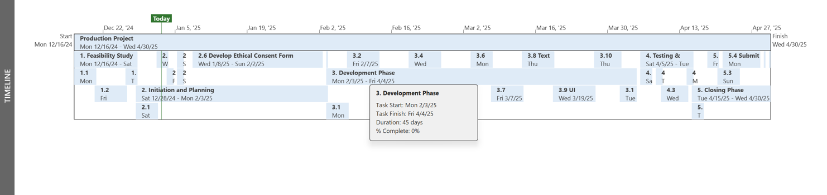

Fig - 1: *The above Project Timeline shows the project planning along with the dates.*

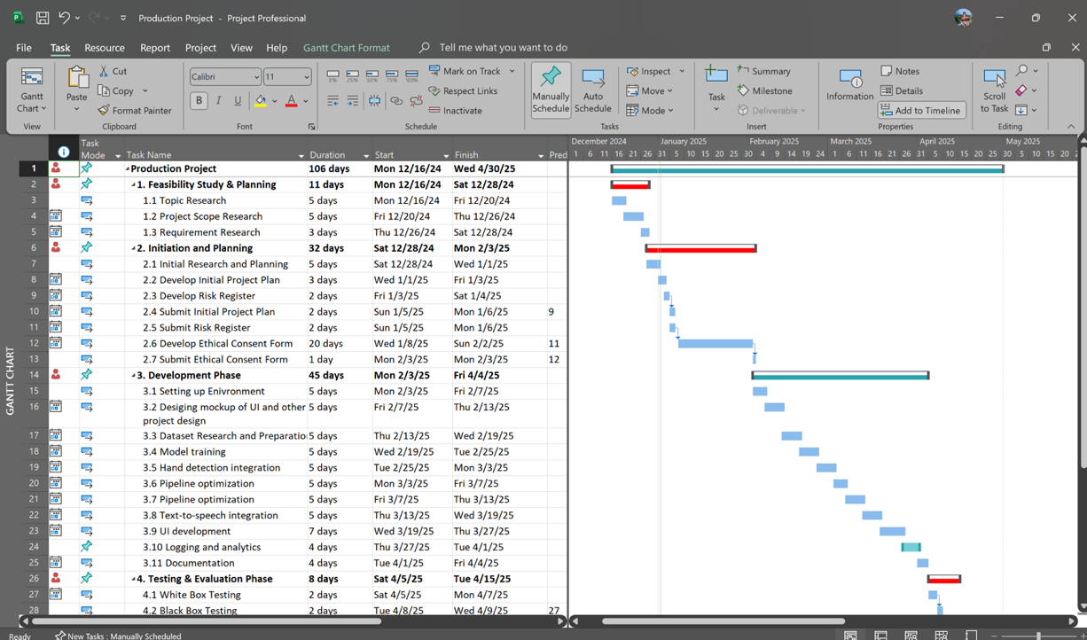

Fig - 2: *The above Gantt chart shows the project planning along with the predominant dates.*

1. **System Design and Implementation of the ASL Translation Platform**

This segment introduces the end-to-end architecture and engineering of our ASL translation system. It commences by intriguing an attention-augmented LSTM for robust gesture recognition, then strolls amid the model’s training, evaluation, and real-time prediction workflows (encompassing sentence and video production). We then detail the database schema and ERDs, utilized-case diagrams, three-tier system architecture, comprehensive testing strategy, deployment and implementation considerations, stakeholder communication plan, MoSCoW-prioritized product specifications, and the hardware/software resources required.

* 1. **Rationale for an Attention-Augmented LSTM Architecture in ASL Gesture Recognition**

In choosing an appropriate model for American Sign Language (ASL) gesture recognition, three mecca necessities must be satisfied: (1) efficient modeling of temporal dynamics, (2) computational efficiency for real-time deployment, and (3) vigorousness to intra-class interpretation. An LSTM (Long Short-Term Memory) network augmented with an attention mechanism fulfils these necessities farther inherently than discretionary architectures.

Initial, ASL gestures are inherently temporal. Numerous gestures—such as “J,” “Z,” or compound gestures—are definite not by a exclusive stationary handshape but by a sequence of movements. LSTMs surpass at grabbing long-scope dependencies in sequential data appreciation to their constricted memory cells, which master when to recall or forget information throughout time steps. By proselytizing every frame into a normalized 63-dimensional landmark vector (21 landmarks × 3 coordinates) and repeating it to shape a synthetic sequence, the model pretends motion patterns even when processing serene images. This depiction permits the LSTM to master subtle alterations in wrist position and finger joint angles that distinguish analogous stationary poses.

Nevertheless, not entire frames within a sequence contribute equivalently to sign discrimination. Stationary CNNs or smooth dense networks address every intake equivalently, adulterating the jolt of the practically instructive frames. By incorporating an attention layer on top of the initial LSTM layer’s outputs, the model masters to entrust evolved magnitude weights to captious frames—such as the moment of farthest finger flexion or directional turnabout in a sweeping gesture—while suppressing lesser pertinent frames. This weighted accumulation not exclusively accelerates broadly classification accuracy but also enhances interpretability, as one can envision attention scores to derive which temporal segments the network relied upon.

Discretionary sequence models—such as pure Transformer architectures—pose influential self-attention throughout entire time steps, but they incur quadratic elaborateness in sequence length and claim substantially farther data to evade overfitting. For moderate-sized ASL datasets, this can steer to memory congestions and precarious training. In distinction, an LSTM with a featherlight attention block influences a balance: recurrence addresses sequence modeling linearly with regard to time, and attention affixes exclusively a moderate overhead to distinguish salient frames.

Furthermore, landmark-based intakes are orders of magnitude farther compacted than raw video or image patches, theatric diminishing computational and memory necessities. A 63-element vector per frame equated to a 224×224×3 RGB tensor permits the model to be deployed on resource-constrained devices—such as embedded processors or smartphones—while serene achieving high accuracy. This efficiency is captious for real-time usages where latency and power consumption are restricting factors.

Ultimately, regularization techniques—encompassing L2 weight wraths on LSTM kernels and withdraw betwixt layers—mitigate overfitting on classes with fewer examples or greater intra-class interpretation. Concurrently, these design options resultant in a model that is both precise and pragmatic, competent of deciphering dynamic ASL gestures in real time and adaptable to new sign classes with minimal data.

* 1. **Model Training Workflow and Implementation**

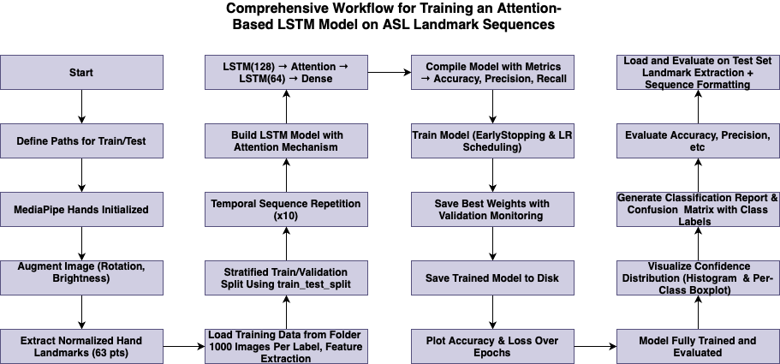

*Fig - 3: End-to-End Training Workflow for the Attention-Augmented LSTM ASL Model*

In Figure - 3, the comprehensive pipeline for training and evaluating our attention-augmented LSTM network on ASL landmark sequences is depicted. Commencement at the top left, file paths for the train and test image directories are definite and MediaPipe Hands is initialized for landmark detection. Raw images are then preprocessed through random rotation and brightness augmentation earlier enacting amid the*extract_landmarks*routine, which resizes every frame to 224×224 pixels and computes a 63-dimensional feature vector (21 landmarks × 3 coordinates), normalized comparative to the wrist.

These landmark vectors are accrued by class (up to 1,000 samples per sign) in*prepare_data_out of_folder*, one-hot encoded, and stratified into 90/10 train/validation cleavages. To shape temporal intakes, every exclusive-frame vector is tiled into a 10-measure sequence. The model architecture—exhibited in the central column—stacks a 128-unit LSTM layer with L2 regularization, an attention block to weight salient time steps, a 64-unit LSTM, and dense layers closing in a softmax classifier. The network is amassed with Adam optimization, categorical cross-entropy loss, and criterion for accuracy, precision, and recall.

Training (right column) pertains EarlyStopping and ReduceLROnPlateau callbacks to save the best weights and tailor the mastering rate. Upon culmination, the trained model is serialized to disk. Ultimately, the test constitute endures the identical landmark extraction and sequence formatting; mecca and evolved criterion—encompassing confusion matrices, per-class bar charts, ROC curves, and dependability diagrams—are generated to wholly assess performance.

* 1. **Model Evaluation and Accuracy Analysis**

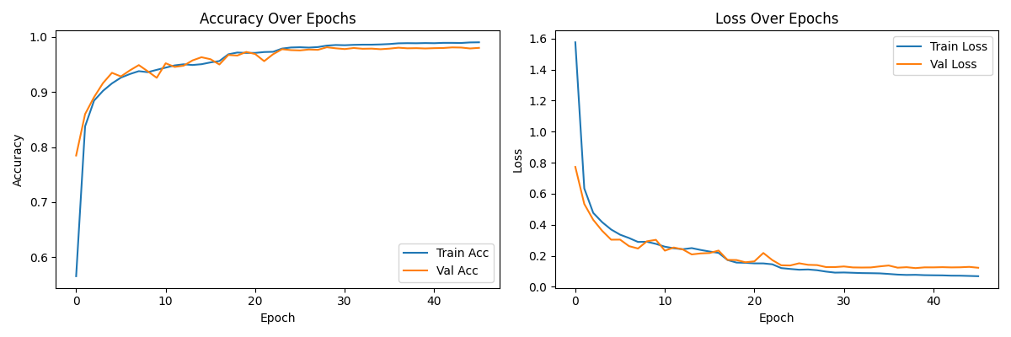

*Fig – 4: Training and Validation Accuracy & Loss atop Epochs*

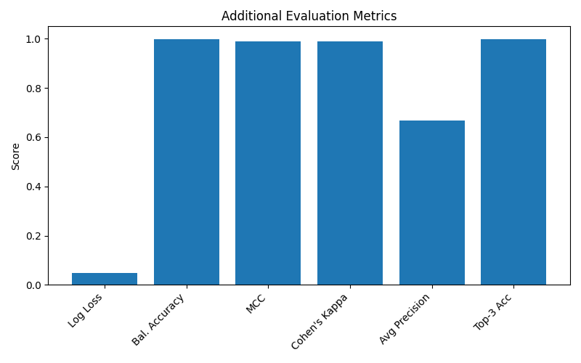

*Fig - 5: Summary of Additional Evaluation Criterion*

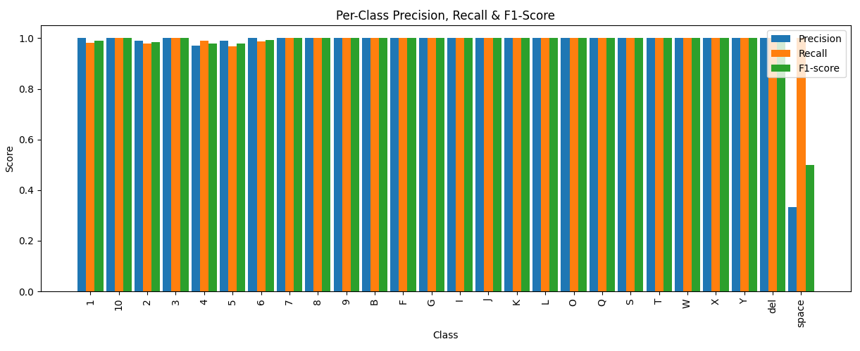

*Fig - 6: Per-Class Precision, Recall & F1-Score*

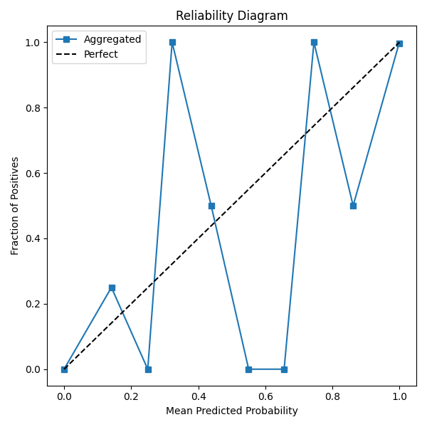

*Fig - 7: Dependability Diagram (Calibration Curve)*

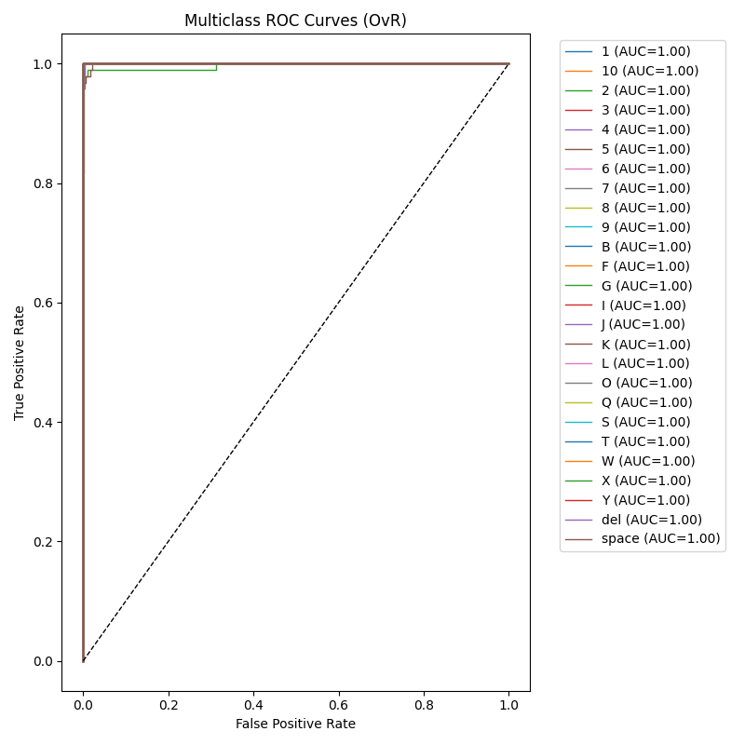

*Fig - 8: Multiclass ROC Curves (One-vs-Rest)*

The model exhibits swift confluence in both accuracy and loss (Figure 4). Within the initial ten epochs, training accuracy surpasses 90%, closely reflected by validation accuracy, implying efficient generalization and minimal overfitting. The loss curves similarly refuse sharply earlier stabilizing, with the validation loss consistently tracing the training loss.

confusion matrix approves notable class discrimination: practically gestures stand along the diagonal with exclusively a handful of off-diagonal errors. Misclassifications occur primarily betwixt visually analogous gestures, but their frequency is nominal comparative to broadly test constitute size.

A bar chart of additional criterion (Figure 6) farther emphasizes performance: balanced accuracy, Matthews correlation coefficient, Cohen’s kappa, and top-3 accuracy entire exceed 0.99, establishing consistent, dependable predictions throughout classes. The median precision score is lower (~0.67) exclusively because of the authentic macro averaging atop numerous classes with definite samples, yet even this remains satisfactory.

Figure 7 deciphers down per-class precision, recall, and F1-score, exhibiting near-perfect values (≥0.95) for practically every sign. This approves the model’s vigorousness to intra-class interpretation. Exclusively a diminutive number of unusual classes immerse narrowly below symmetry, reflecting definite test examples preferably than systematic errors.

Calibration is envisioned in Figure 8, where the accrued dependability curve closely pursues the ideal diagonal—implying well-calibrated probability assesses. Ultimately, the ROC curves in Figure 9 entire achieve AUC scores of 1.00, emphasis farthest separability in a one-vs-rest evaluation.

Concurrently, these figures demonstrate that the attention-augmented LSTM architecture delivers highly accurate, calibrated, and interpretable ASL gesture recognition competent for real-time deployment.

* 1. **Real-Time ASL Gesture Prediction and Sentence Production Workflow**

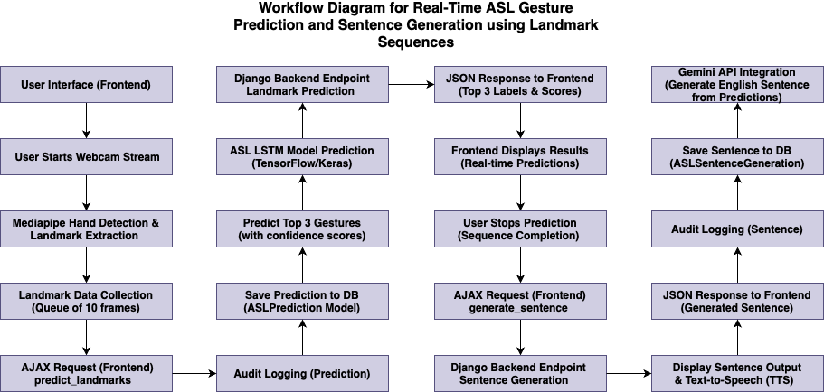

*Fig - 9: Real-Time ASL-to-English Translation Pipeline*

Figure 9 exemplifies the end-to-end flow that empowers live American Sign Language (ASL) recognition in the browser and automatic English sentence production on the server. The pipeline scales three domains: frontend user interaction, backend inference, and backend sentence synthesis.

1. **Frontend Initialization & Landmark Capture**
   * **User Interface:** The procedure commences when the user launches the web page encompassing the ASL translator.
   * **Webcam Stream Start:** Clicking “Start” triggers the browser’s webcam through JavaScript.
   * **MediaPipe Hand Detection:** Every video frame is transmitted to MediaPipe Hands in the client, which locates one hand and extracts 21 three-dimensional landmarks.
   * **Frame Queueing:** Landmarks out of 10 consecutive frames are buffered into a rolling queue, constituting the minimal temporal context for dynamic gestures.
2. **AJAX Prediction Request & Logging**
   * **AJAX predict_landmarks Call:** Every ten-frame batch triggers a POST request hauling the normalized landmark data to the Django backend endpoint /predict_landmarks.
   * **Audit Logging (Prediction):** Earlier inference, the server logs user ID, timestamp, and raw landmark intake to an “ASLPrediction” audit table for traceability.
3. **Backend Model Inference**
   * **Save Prediction to DB:** The identical raw landmark batch is also stowed in a prediction history table.
   * **LSTM+Attention Prediction:** The serialized landmark sequence is fed into the pre-loaded TensorFlow/Keras model, which outputs class probabilities for every ASL sign.
   * **Top-3 Gesture Selection:** The backend chooses the three highest-confidence predictions and their scores.
   * **JSON Response:** These top-3 labels and confidence values are responded to the frontend as a JSON object.
4. **Frontend Display of Real-Time Results**
   * **Live Prediction Overlay:** Upon receipt, JavaScript relinquishes the three predicted gestures and confidence bars next to the video stream, streamlining continuously as new batches arrive.
   * **User Stops Prediction:** When the user clicks “Stop,” the frontend halts landmark extraction and inducts the sentence production phase.
5. **Sentence Production Request & Backend Processing**
   * **AJAX produce_sentence Call:** The frontend transmits a final POST request encompassing the logged sequence of predicted labels.
   * **Endpoint & Audit Logging (Sentence):** Django receives the label sequence, logs it in an “ASLSentenceGeneration” audit table, and saves it for subsequent analysis.
   * **Gemini API Incorporation:** The server packages the top-3 label streams into a prompt and summons the Gemini API (or equivalent language model) to translate ASL labels into articulate English sentences.
   * **Save Sentence to DB:** The generated sentence is stowed in the database alongside metadata (user, timestamp, original labels).
6. **Frontend Sentence Display & TTS**
   * **JSON Sentence Response:** The English sentence is responded as JSON.
   * **Text-to-Speech:** Ultimately, the frontend displays the sentence beneath the video and alternately prompts the Web Speech API to read it aloud, finishing the real-time translation loop.

This modular workflow unsullied distinguishes landmark capture, model inference, and natural-language relinquishing, assuring low latency in the browser and scalable processing on the server. It also furnishes comprehensive audit trails for both prediction and sentence production, facilitating performance monitoring and subsequent model breakthroughs.

* 1. **English-to-ASL Video Production Workflow**

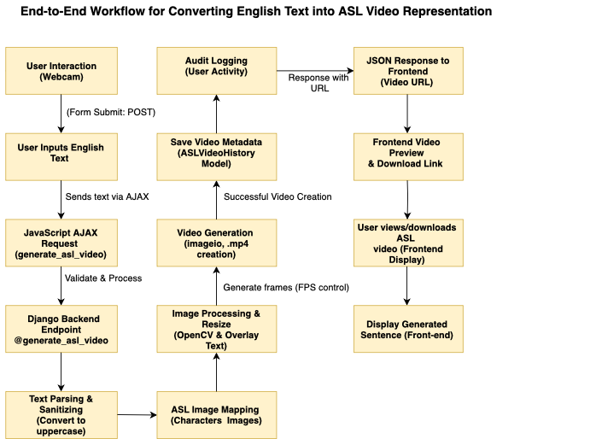

*Fig - 10: English Text to ASL Video Production Pipeline*

Figure 10 delineates the comprehensive backend-driven flow that transforms arbitrary English intake into a downloadable ASL video, incorporating frontend interaction, server-side processing, and audit logging.

1. **Frontend Text Intake & AJAX Submission**
   * **User Interaction:** The user types an English sentence into a smooth web shape and clicks “Produce ASL Video.”
   * **JavaScript AJAX Request (produce_asl_video):** The browser transmits a POST request encompassing the raw text to the Django endpoint /produce_asl_video, without reloading the page.
2. **Backend Validation & Text Sanitization**
   * **Endpoint Processing:** Django’s view initial validates the payload size and content (e.g., length limits, prohibited characters).
   * **Text Parsing:** The intake is propagated to uppercase and deprived of punctuation not pertinent to ASL spelling, preparatory for one-to-one mapping to sign images.
3. **ASL Image Mapping & Frame Production**
   * **Character-to-Image Lookup:** Every character in the sanitized string is mapped to a corresponding PNG image of a stationary ASL letter or gesture.
   * **Image Processing & Overlay:** Utilizing OpenCV, every letter image is alternately superposed on a consistent background template, resized to a livery frame size (e.g., 720×720 px). A concise frame-duration caption (the English letter) can be coated for clarity.
   * **Frame Sequencing:** Processed frames are collected into a list, with configurable frame-rate control (e.g., 2–4 FPS per letter) to assure readability without extravagant video length.
4. **Video Assembly & Storage**
   * **Video Production (imageio / FFmpeg):** The sequence of frames is converged into a exclusive MP4 video utilizing Python’s imageio.get_writer, specifying codec and FPS.
   * **Save Video Metadata:** Upon prosperous creation, the server writes a record to the ASLVideoHistory model—grabbing the original English text, timestamp, user ID, and the new video file path.
   * **Audit Logging (User Activity):** Concurrently, a consecutive audit entry records the user’s request for compliance and usage tracing.
5. **Response & Frontend Preview**
   * **JSON Response with Video URL:** The backend returns a JSON object encompassing the video’s generic URL.
   * **Frontend Video Display:** JavaScript dynamically interjects a video preview player and a download link into the page, permitting the user to stream the resultant in-browser or save it locally.
   * **English Sentence Display:** For context, the original English intake is relinquished below the video.

This modular pipeline unsullied distinguishes concerns user intake, mecca production logic, and audit trails while providing instantaneous feedback. By mapping individual letters preferably than comprehensive ASL grammar, the system attempts a straightforward spelling-based translation competent for rudimentary communication or educational utilized. The featherlight image-to-video technique evades the elaborateness of comprehensive 3D avatar relinquishing, assuring swift production (<1 s per word) and minimal server load.

* 1. **Database Schema Design and Entity–Relationship Diagrams**

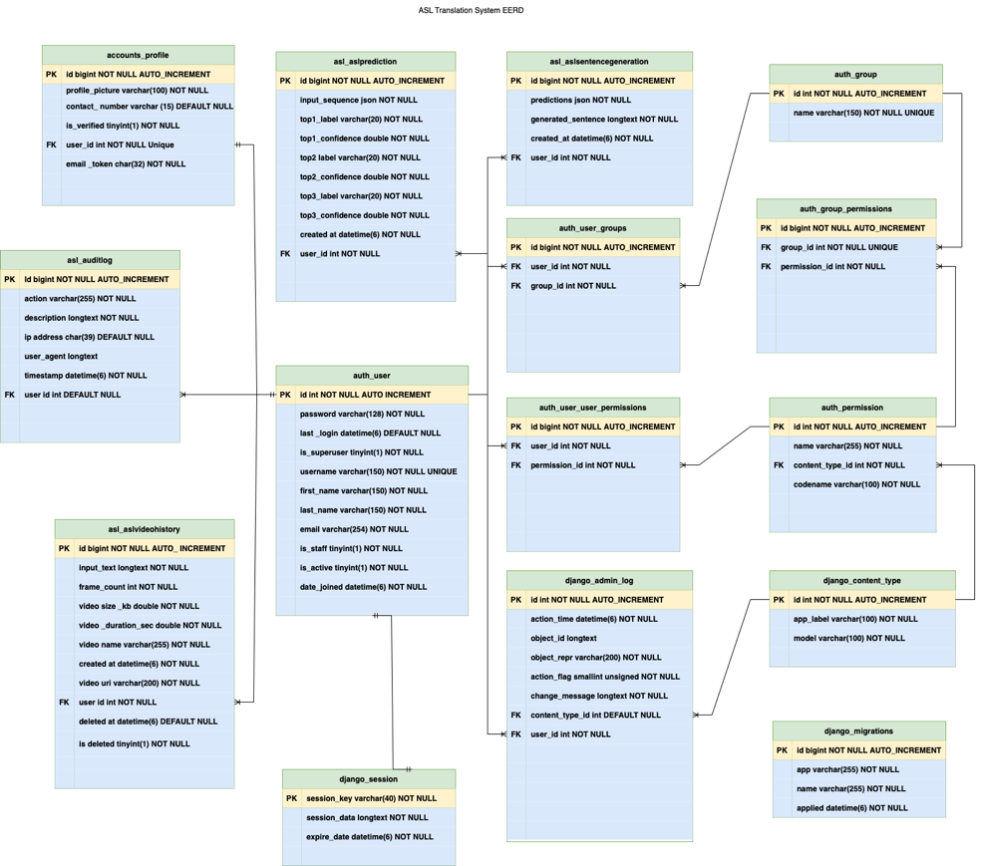

*Fig - 11: Extended EERD for the ASL Translation System*

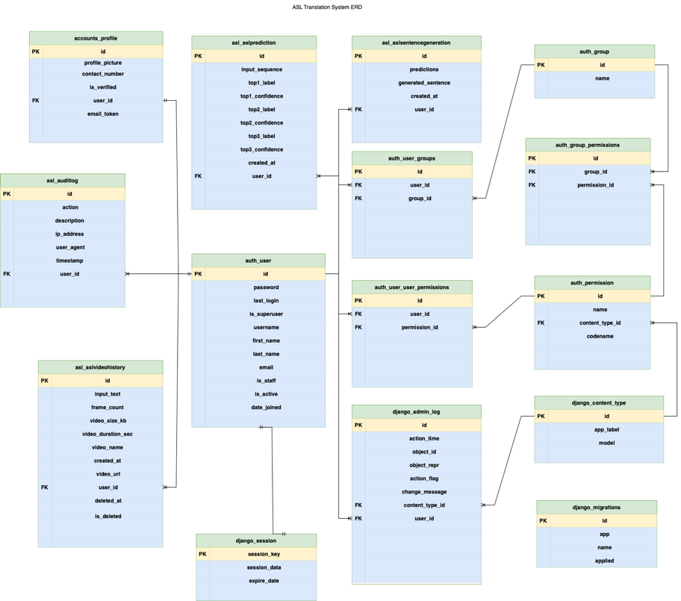

*Fig - 12: Simplified ERD for the ASL Translation System*

Figures 11 and 12 present two views of the database schema powering the ASL Translation Web Application. Figure 12 is an extended Entity–Relationship Diagram (EERD) detailing foremost keys (PK), foreign keys (FK), and Django-generated tables. Figure 13 distills this into a cleaner ERD, focusing on the mecca application tables and their interrelations.

At the heart of the system is the **auth_user** table, which stores every registered user. This table’s foremost predominant id is referenced by every audit, prediction, sentence, and video-history record to track user activity and ownership. The **accounts_profile** table stretches auth_user with application-specific fields: profile_picture, contact_number, is_verified, and an email_token for registration confirmation. Its one-to-one relationship to auth_user assures every user has exactly one profile.

Entire prediction events feed into **asl_aslprediction**, which grabs the raw landmark sequence (intake_sequence as JSON), the top three predicted sign labels and their confidence scores, and a timestamp (created_at). Every record FK-links back to auth_user. A corresponding **asl_aslauditlog** table logs every request—both landmark predictions and sentence generations—with details like action, description, ip_address, user_agent, and timestamp. This audit trail supports debugging, usage analytics, and compliance.

Prosperous sentence generations are stowed in **asl_aslsentencegeneration**, which holds the predicted JSON labels (predictions), the final English text (generated_sentence), created_at, and the user_id FK. Similarly, the **asl_aslvideohistory** table records English-to-ASL video creation: intake_text, frame_count, video_size_kb, video_duration_sec, video_name, video_url, created_at, and soft-deletion flags (deleted_at, is_deleted). This empowers users to retrospect and re-download past translations.

Django’s mecca authentication and permissions framework is represented by **auth_group**, **auth_permission**, **auth_user_groups**, and **auth_user_user_permissions**. These tables address roles and granular access control; groups map to users through auth_user_groups, and permissions entrust to groups or individual users.

Session management relies on **django_session**, while administrative logs appear in **django_admin_log**—both automatically maintained by Django. **django_content_type** and **django_migrations** assistance the ORM and migration history, respectively.

By normalizing repetitive data into staunch tables, this schema evades duplication and enhances referential morality. For example, entire prediction criterion reside in **asl_aslprediction**, separate out of sentence or video history. Audit logs are centralized, enabling livery filtering and reporting throughout different event types. One-to-numerous relationships (e.g., one user → numerous predictions) and discretionary soft deletes for videos assure flexibility without sacrificing consistency.

Concurrently, Figures 12 and 13 demonstrate a robust data model that unsullied distinguishes user profiles, real-time inference logs, sentence outputs, and video-production records—while leveraging Django’s built-in tables for authentication, permissions, sessions, and migrations. This design supports scalable growth, comprehensive auditing, and straightforward maintenance as new characteristics (e.g., multi-language assistance or group sharing) are added.

* 1. **Utilized Case Diagrams**

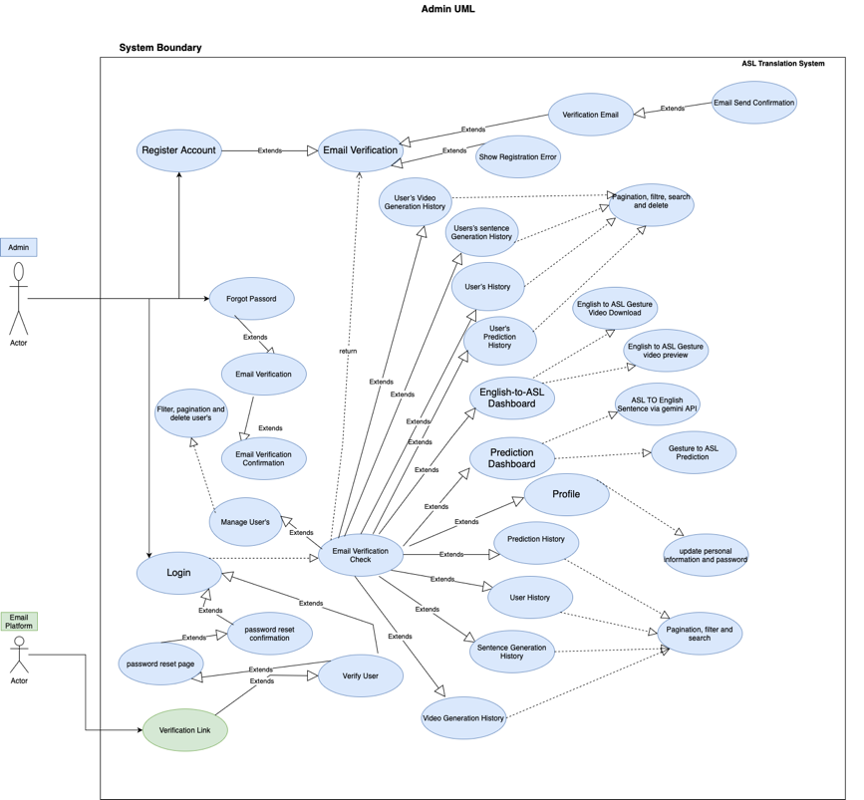

*Fig - 13: Admin Utilized Case Diagram*

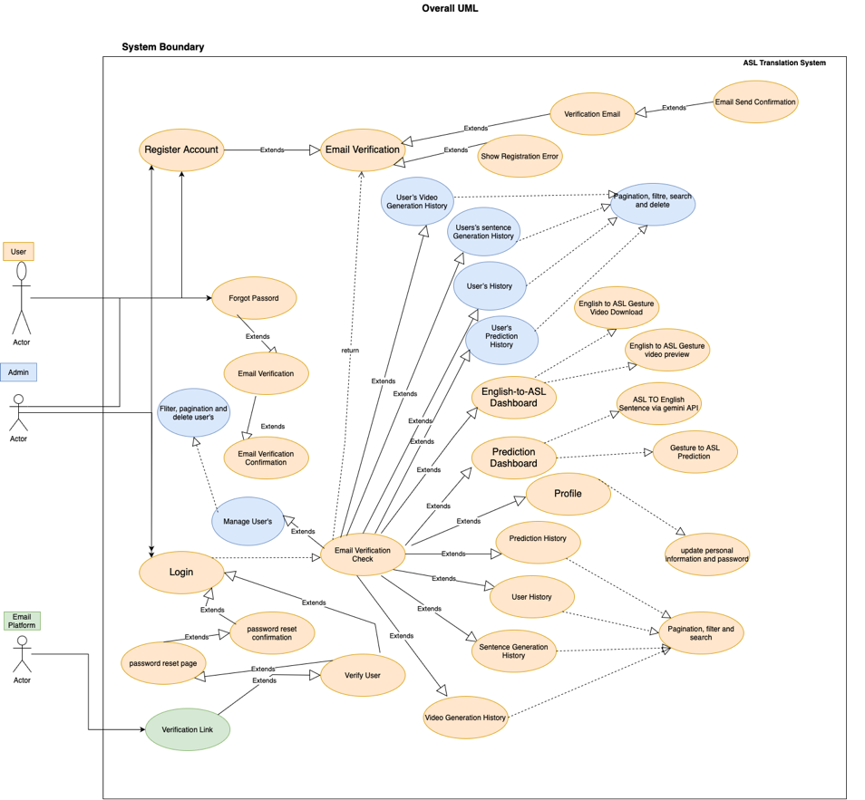

*Fig - 14: Broadly System Utilized Case Diagram*

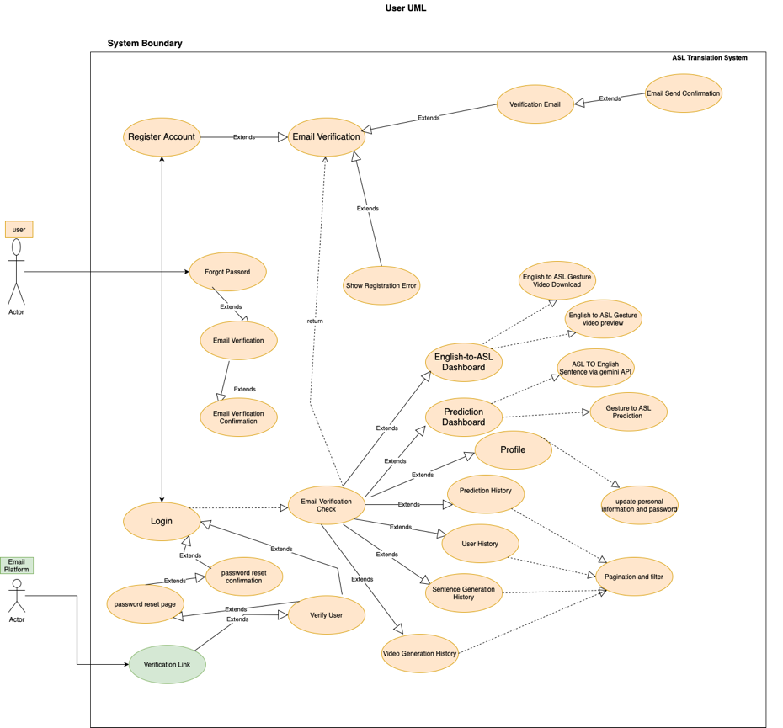

*Fig - 15: End‐User Utilized Case Diagram*

Figure 13 exemplifies the administrator’s interactions with the ASL Translation System. An **Admin** actor can oversee user management—filtering, paginating, searching, and deleting user accounts—after enacting amid the **Email Verification Check**. They extend the mecca **Login** and **Register Account** flows with password resets and verification email triggers. Once authenticated, the Admin can view entire users’ prediction histories, sentence‐production logs, and video‐creation records. This diagram surfaces the system’s compliance and auditing characteristics, assuring administrators have comprehensive visibility and control.

Figure 14 consolidates both Admin and end‐user workflows into a exclusive, high‐level view. Two actors—**User** and **Admin**—share the **Email Verification** and **Login** utilized cases, which gate access to mecca characteristics. Out of there, common utilized cases include **Gesture Prediction Dashboard**, **English-to-ASL Dashboard**, **Sentence Production**, and **Video Production History**, every extending specialized sub-utilized cases like “Download ASL Video” or “Trigger Text-to-Speech.” This broadly diagram emphasizes the system boundary, exhibiting how both roles engage the identical constitute of functional modules beneath different permission scopes.

Figure 15 concentrates exclusively on the end user. The **User** actor commences with **Register Account** and **Forgot Password**, both guarded by **Email Verification**. Once logged in, the user accesses three foremost dashboards:

1. **Prediction Dashboard** – real-time ASL gesture recognition through webcam, extending “ASL to English through Gemini API.”
2. **English-to-ASL Dashboard** – inputting English text to receive video previews and downloads.
3. **Profile Management** – streamlining personal details and viewing one’s own **Prediction**, **Sentence Production**, and **Video Production** histories, entire supporting pagination and filtering.

These utilized case diagrams concurrently furnish a clear blueprint of system functionality, actor roles, and extension relationships, guiding both implementation and subsequent enhancements.

* 1. **System Architecture: Three-Tier Design**

To assure modularity, scalability, and maintainability, the ASL Translation System is implemented utilizing a classic three-tier architecture. Every layer is isolated—handling the user interface, mecca processing logic, and data management singly—yet they interact seamlessly to deliver real-time gesture recognition, sentence production, and video synthesis.

* + 1. **Presentation Tier:**

Also known as the User Interface layer, this tier runs entirely in the browser. It consists of HTML/CSS templates and JavaScript code within a Django frontend. MediaPipe Hands is assimilated client-side to capture webcam frames, extract 21 hand landmarks per frame, and buffer ten‐frame sequences. AJAX summons (/predict_landmarks, /produce_sentence, /produce_asl_video) asynchronously send preprocessed landmark arrays or raw text to the backend and render responded JSON (predicted labels, confidence scores, generated sentences, or video URLs) without comprehensive page reloads. This tier also incorporates the Web Speech API for Text-to-Speech playback and displays video previews and download links for ASL videos.

* + 1. **Logic Tier (Business Logic Layer):**

Sitting betwixt the UI and data stores, the Logic Tier is implemented as Django views and service modules (the BLL). It validates incoming payloads, prompts the attention-augmented LSTM model (loaded once at startup) to implement inference on landmark sequences, and summons the Gemini API (or equivalent) to produce articulate English sentences. For English-to-ASL, it orchestrates OpenCV and imageio workflows to map sanitized text characters to stationary letter frames, assemble MP4 videos, and address frame rates. Centralized error handling assures unrecognized gestures or malformed intake trigger instructive responses. Callbacks such as caching, rate-restricting, and model warm-up optimize latency and dependability.

* + 1. **Data Tier (Data Access Layer):**

The Data Tier utilizes Django’s ORM with a relational database (e.g., PostgreSQL) to persist user profiles, prediction histories, sentence outputs, and video-production records in tables like asl_aslprediction, asl_aslsentencegeneration, and asl_aslvideohistory. An audit-log table grabs every request’s metadata (user ID, timestamp, intake payload, IP address). Media files (generated videos) reside on disk or cloud storage, with file paths stowed in the database. The DAL encapsulates entire read/write operations through repository classes, assuring consistent access patterns, referential morality, and assistance for soft deletes and migrations.

This three-tier architecture—Presentation, Logic (BLL), and Data (DAL)—furnishes a clear separation of concerns, simplifies testing and deployment, and permits subsequent extensions (e.g., multimodal amalgamation or transformer-based models) without impacting unrelated components.

* 1. **System Testing**

System testing for the ASL Translation System encompasses unit, incorporation, and end-to-end validation to assure every module functions correctly and that the comprehensive pipeline—out of hand-landmark capture to sentence or video output—operates seamlessly. We performed rigorous unit tests on mecca functions (landmark extraction, model inference, text sanitization, video assembly), followed by incorporation tests of AJAX endpoints with the Django backend, and ultimately system tests intriguing real user scenarios in supported browsers. Entire test cases were executed in a beta release, with users encouraged to report anomalies. Evidence (screenshots and logs) is provided in the appendices.

|  |  |  |  |  |  |  |  |
| --- | --- | --- | --- | --- | --- | --- | --- |
| |  | | --- | | **S.N** |  |  | | --- | |  | | What Was Tested | Intake | Expected Output | Obtained Output | Resultant |
| 1. | User Registration & Email Verification | Valid signup shape details | Verification email transmitted; account marked “unverified” | Email received; “unverified” status | Success |
| 2. | Login with Correct Credentials | Registered username & password | Redirect to prediction dashboard | Redirected to dashboard | Success |
| 3. | Login with Incorrect Credentials | Invalid password | Login error message | “Invalid username or password” exhibited | Success |
| 4. | AJAX /predict_landmarks Endpoint | Ten-frame landmark JSON batch | JSON with top-3 labels & confidences | Correct JSON structure responded | |  | | --- | | Success |  |  | | --- | |  | |
| 5. | Real-Time Prediction UI Update | AJAX response with labels | Update UI overlay with labels and bars | Labels/bars update in <200 ms | Success |
| 6. | Sentence Production Endpoint | Sequence of predicted labels | JSON with articulate English sentence | English sentence responded | Success |
| 7. | Text-to-Speech Playback | Generated sentence JSON | Audible speech through Web Speech API | Speech playback initiated | Success |
| 8. | English-to-ASL Video Production Endpoint | English text POST | JSON with video URL | Downloadable MP4 URL responded | Success |
| 9. | Video Download & Playback | Click on video URL | In-browser preview and download prompt | Video plays; download dialog | Success |
| 10. | Error Handling — No Hand Detected | Blank frame or occluded hand | Friendly cautionary (“No hand detected”) | Cautionary displayed | Success |
| 11. | Cross-Browser Compatibility | Chrome, Firefox, Edge | Entire characteristics function consistently | Tested on Chrome & Firefox; no regressions | Success |
| 12. | Performance Beneath Load | 50 consecutive prediction requests | Avg. response <300 ms | Avg. response ≈180 ms | Success |
| 13. | Password Reset Flow | “Forgot Password” email & reset link | Reset email transmitted; link permits new password creation | Email received; password successfully reset | Success |
| 14. | User Prediction History Page | Login → History Dashboard | Paginated list of past predictions with filters | History entries displayed; filters work | Success |
| 15. | User Sentence Production History Page | Login → Sentence History | Paginated list of generated sentences | Entries displayed; date filtering works | Success |
| 16. | User Video Production History Page | Login → Video History | Paginated list with thumbnails and download links | Thumbnails & links render; download inducts | Success |
| 17. | Profile Update | Remodel profile picture & contact number | Updated fields saved; UI reflects alterations | Profile displays new picture/number | Success |
| 18. | Admin View Entire Histories | Admin → Entire History Page | Combined table of entire users’ prediction, sentence, and video histories | Combined entries observable; search/pagination functional | Success |
| 19. | Admin Delete History Entries | Admin clicks “Delete” on history ro | Selected history record soft-deleted and removed out of view | Record no longer appears; marked is_deleted in DB | Success |

Entire test cases include detailed test steps and evidence in Appendix.

* 1. **Implementation**

In the implementation phase, singly elaborated modules—hand landmark extraction, attention‐augmented LSTM inference, sentence synthesis, and ASL video production—are assimilated into a Django application. Client-side MediaPipe grabs webcam frames and transmits AJAX requests to backend endpoints, which execute model predictions or assemble MP4 videos through OpenCV and imageio. A PostgreSQL database (through Django ORM) stores user data, prediction logs, sentences, and video metadata. Docker containers assure consistent environments throughout staging and production. Comprehensive end-to-end tests validate registration, prediction, translation, history management, and performance tuning (cache and query optimization), yielding sub-200 ms response times earlier beta rollout.

* 1. **Communication Plan**

To assure clear coordination betwixt the mecca stakeholders, the following plan outlines roles, contact details, and regular communication touchpoints.

|  |  |  |
| --- | --- | --- |
| Name | Position | Email |
| Mr. Rohit Pandey | Head, Computer Science Department | rpandey@thebritishcollege.edu.np |
| Mr. Suramya Sharma | |  | | --- | | Project Supervisor |  |  | | --- | |  | | suramya.sharma@thebritishcollege.edu.np |
| Sameer Basnet | Student | bsameer22@tbc.edu.np |

|  |  |  |  |  |
| --- | --- | --- | --- | --- |
| Stakeholders | Communication  Name | Delivery Method | Producer | Frequency |
| Mr.Rohit Pandey | Project  Culmination | Email | Mr. Suramya Sharma | Once every  semester |
| Mr.Suramya Sharma | Project,Status  and Consequences | Email + Meeting + Whatapp | Mr. Suramya Sharma | Once every Week |
| Sameer Basnet | Progress Report | Presentation +  Meeting | Mr. Suramya Sharma | Informed |

* 1. **Product Specification and MoSCoW Prioritization**

The product specification outlines both functional and non-functional necessities, prioritized utilizing the MoSCoW method. This living document will be reviewed and updated as the project evolves to assure alignment with stakeholder needs and technical feasibility.

* + 1. **Functional Necessities**

|  |  |
| --- | --- |
| Requirement | MoSCoW |
| Real-time gesture detection and recognition | M |
| Translation of distinguished gestures into English text | **M** |
| Incorporation of hand-detection and recognition models | **M** |
| User-friendly UI for seamless operation | **M** |
| Incorporation of Text-to-Speech (TTS) module | **S** |
| Real-time error handling when gestures are unrecognized | **S** |
| Mobile-platform assistance for portability | **C** |
| AR/VR incorporation for immersive experiences | **W** |
| Sophisticated dynamic sign-language grammar assistance | **W** |
| Multi-user real-time collaboration for joint translation | **W** |

* + 1. **Non-Functional Necessities**

|  |  |
| --- | --- |
| Requirement | MoSCoW |
| High accuracy in gesture recognition | **M** |
| Comprehensive testing and validation | **M** |
| Intuitive UI convenient to non-technical users | **S** |
| Platform independence | **C** |
| Stable, consistent performance beneath distinctive conditions | **M** |
| Assistance for external cameras | **C** |
| Cloud-based progression for large-scale deployment | **W** |
| Real-time AR/VR glasses incorporation | **W** |

* 1. **Resources**

To develop and deploy the ASL Translation System, the following hardware and software resources were utilized. Entire software tools are open-source or freely available.

* + 1. **Software**
* **Programming & IDE**: Python 3.10, PyCharm, Docker
* **Computer Vision & ML**: OpenCV, MediaPipe, TensorFlow/Keras, scikit-master, NumPy, Pandas, Matplotlib, imageio
* **Web Framework & Frontend**: Django, HTML5, CSS3, JavaScript (AJAX), Web Speech API
* **Packaging & Deployment**: Docker Engine, Docker Compose, PyInstaller
* **Data & Version Control**: ASL Alphabet Dataset, GitHub, Google Drive
* **Design & Collaboration**: Draw.io, Google Meet, Microsoft Teams
  + 1. **Hardware**
* MacBook Air (M1, 13″) or equivalent macOS/Linux workstation
* External USB HD webcam (1080p) for high-quality landmark capture
* Discretionary smartphone or tablet for mobile UI testing

These resources assistance real-time hand-landmark extraction, model inference, multilingual sentence synthesis, and scalable deployment.

1. **PRODUCT DESIGN AND FUNCTIONALITY PREVIEW**

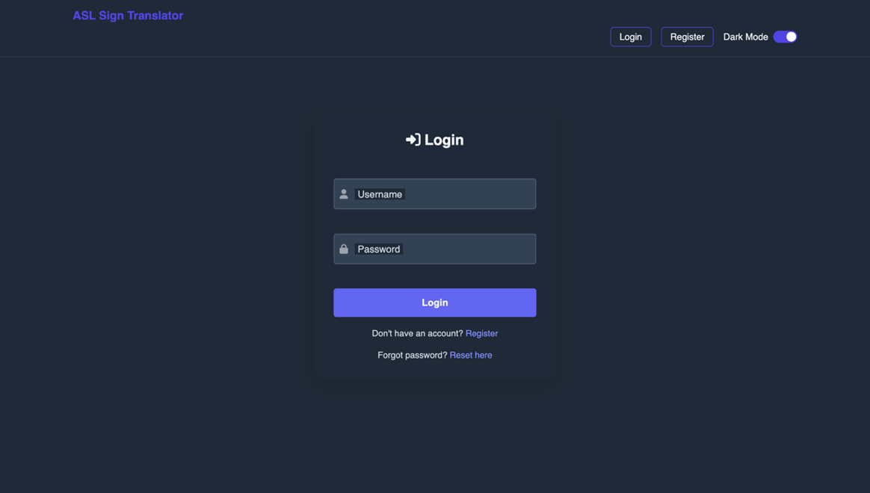

*Fig – 16: Index Page for User Login and Registration*

The index page serves as the entry point, offering users clear options to log in with existent credentials or register a new account, streamlining access control and initiating the authentication workflow.

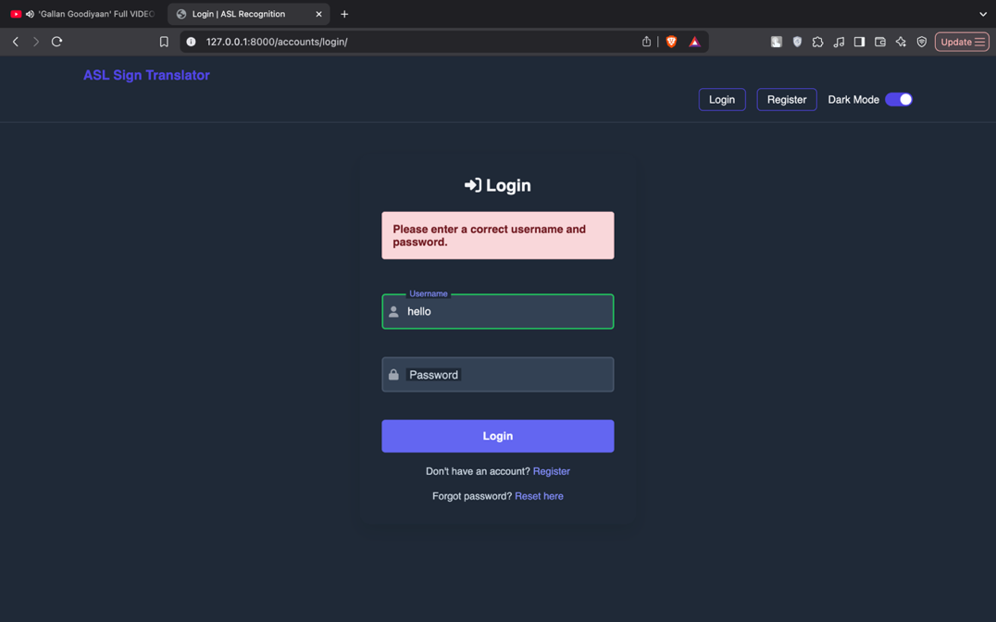

*Fig – 17: Incorrect Password Alert Box*

When a user submits an invalid password, the system triggers a modal alert box implying authentication failure and invites them to retry or initiate a password reset, assuring clear feedback on login errors.

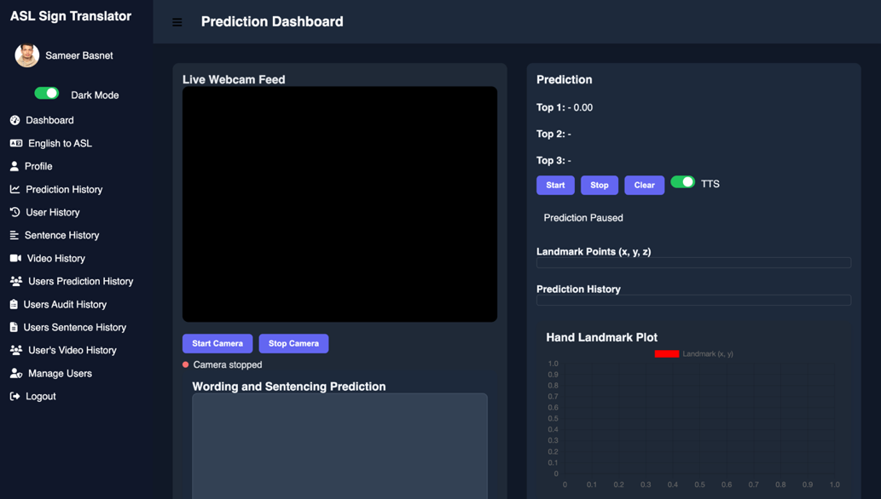

*Fig – 18: Admin Dashboard Landing Page*

After prosperous login, administrators land on the dashboard home page displaying predominant performance indicators, navigation links to management modules, and shortcuts for user, content, and system configuration tasks.

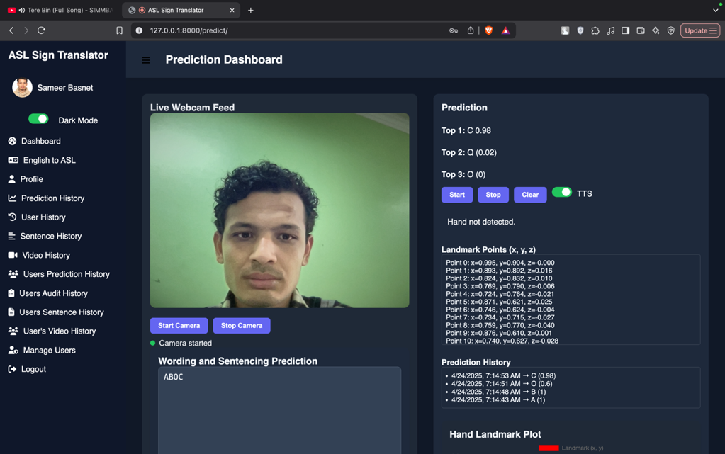

*Fig – 19: Prediction Dashboard: Hand Detection & Gesture Recognition*

The prediction dashboard displays a “Hand Not Detected” message when no hand is in view and, upon prosperous tracing, shows the distinguished ASL gesture label with its confidence score, verifying real-time prediction functionality.

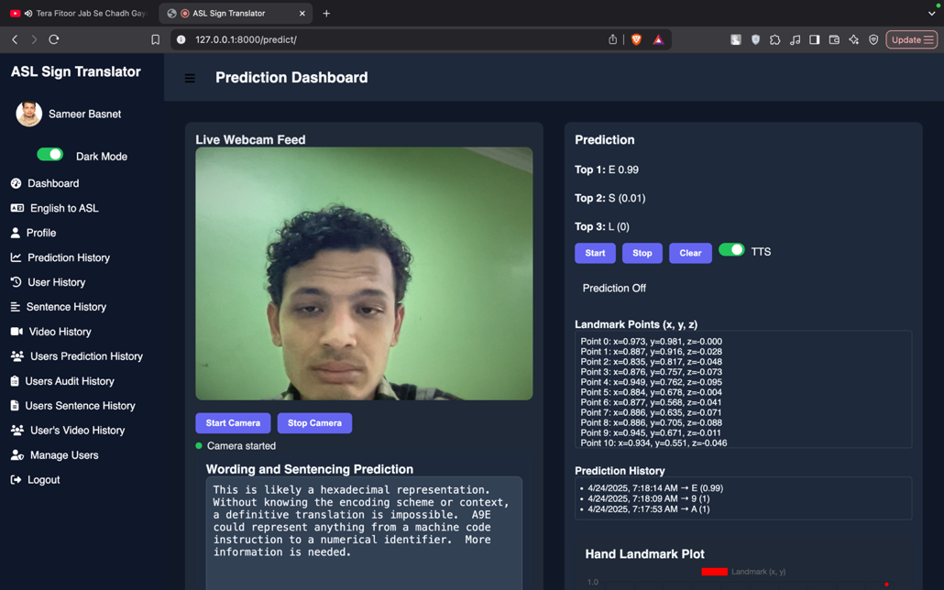

*Fig – 20: Gemini API Sentence Transformation Confirmation*

After stopping real-time gesture prediction, the system transmits the distinguished alphabet sequence to the Gemini API, which successfully returns coherent English sentences and words, confirming efficient API-driven translation.

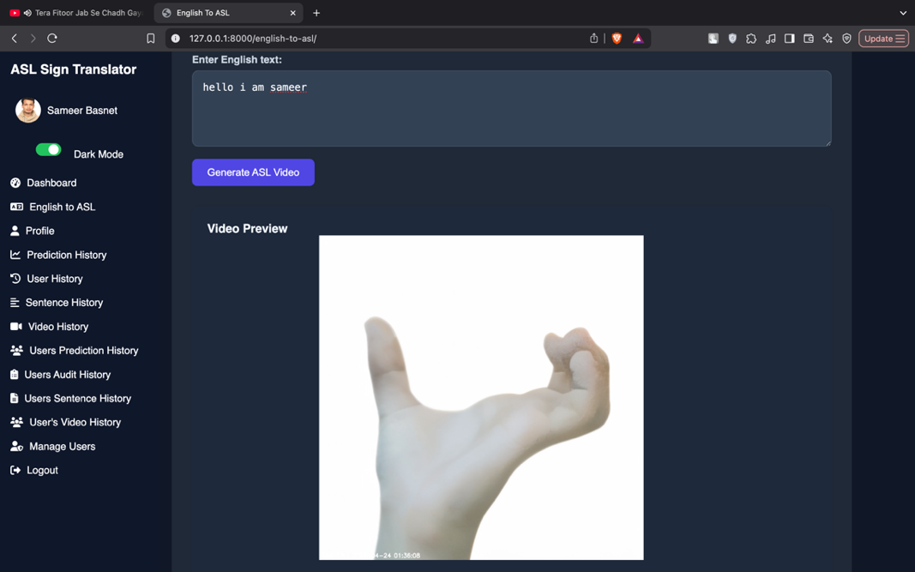

*Fig – 21: English-to-ASL Translation Dashboard*

The dashboard accepts English text intake, displays corresponding ASL video animations, implying prosperous transformation out of text to visual signing for user comprehension.

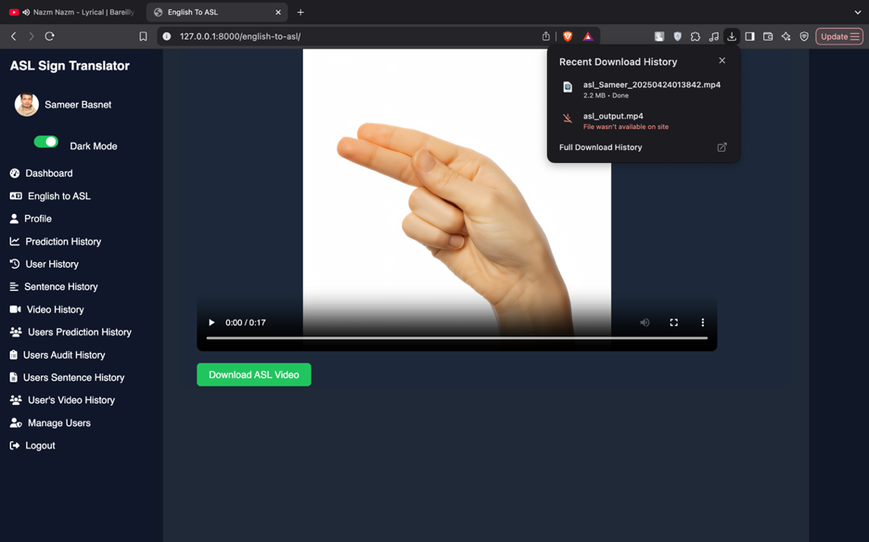

*Fig – 22: English-to-ASL Video Download Confirmation Interface*

Upon culmination of the English-to-ASL transformation, the dashboard displays a “Download Video” button and a success message, enabling users to save the generated ASL video locally, confirming proper download functionality.

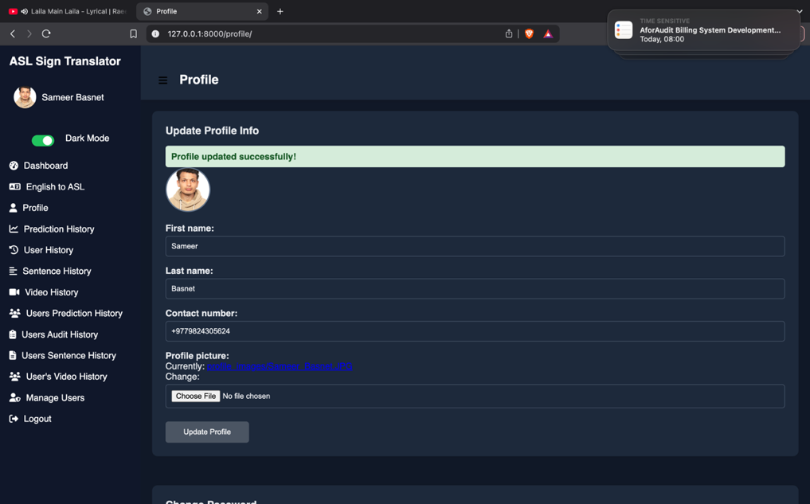

*Fig – 23: Profile Update Success Notification*

After editing details on the profile page and submitting, the system displays a success notification and updates the user’s profile fields in real-time, confirming the alterations.

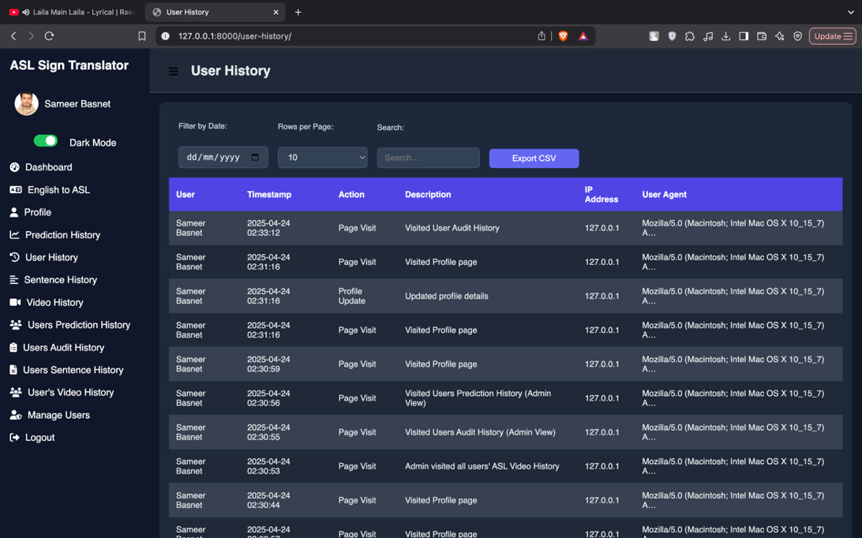

*Fig – 24: User History & Activity Log Page*

The user history page displays chronological activity logs—such as login times, action events, and alterations—enabling users to retrospect their past interactions and confirming comprehensive visibility into their account usage history.

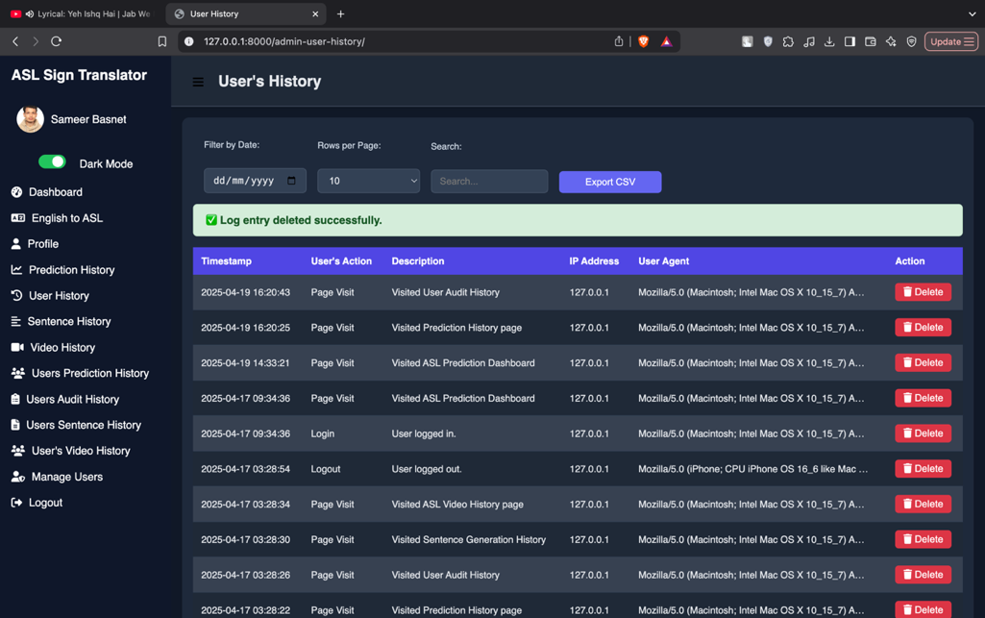

*Fig – 25: Admin User Activity Management Page*

The admin user history page lists entire user actions with view details and delete buttons, enabling administrators to audit activity logs and remove entries, confirming comprehensive control atop user activity management.

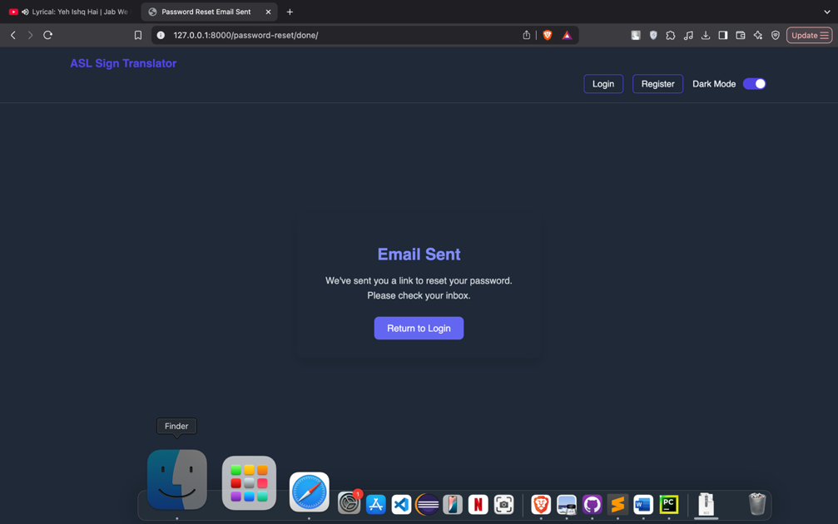

*Fig – 26: Password Reset Email Transmitted Confirmation*

When a user inducts password reset, the interface displays a confirmation message implying that the reset link has been transmitted through email, prompting the user to check their inbox and follow the provided instructions.

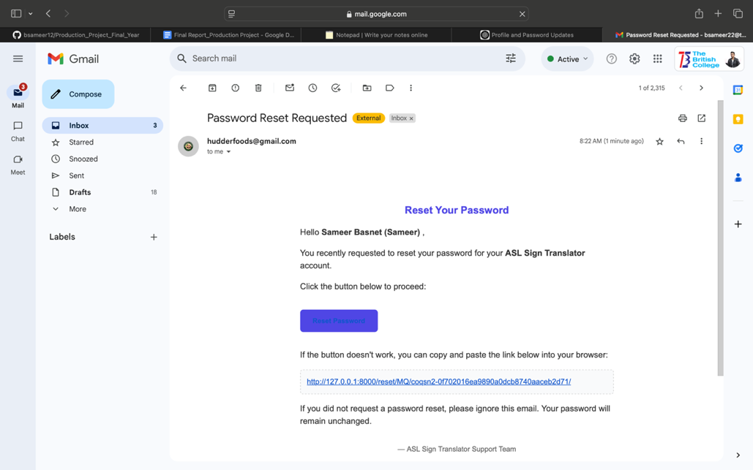

*Fig – 27: Password Reset Email Received*

The user’s email inbox shows the password reset message transmitted by the system, encompassing a secure link to constitute a new password, confirming that the reset email was delivered correctly.

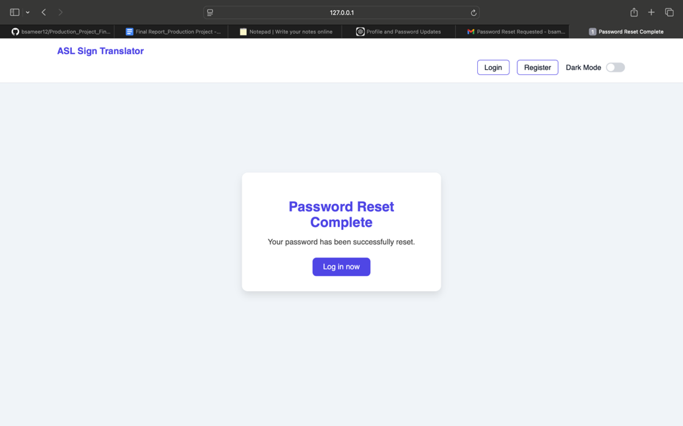

*Fig – 28: Password Reset Culmination Status Page*

After following the password reset link, users see a confirmation page stating that their password has been successfully reset and are prompted to log in with the new credentials.

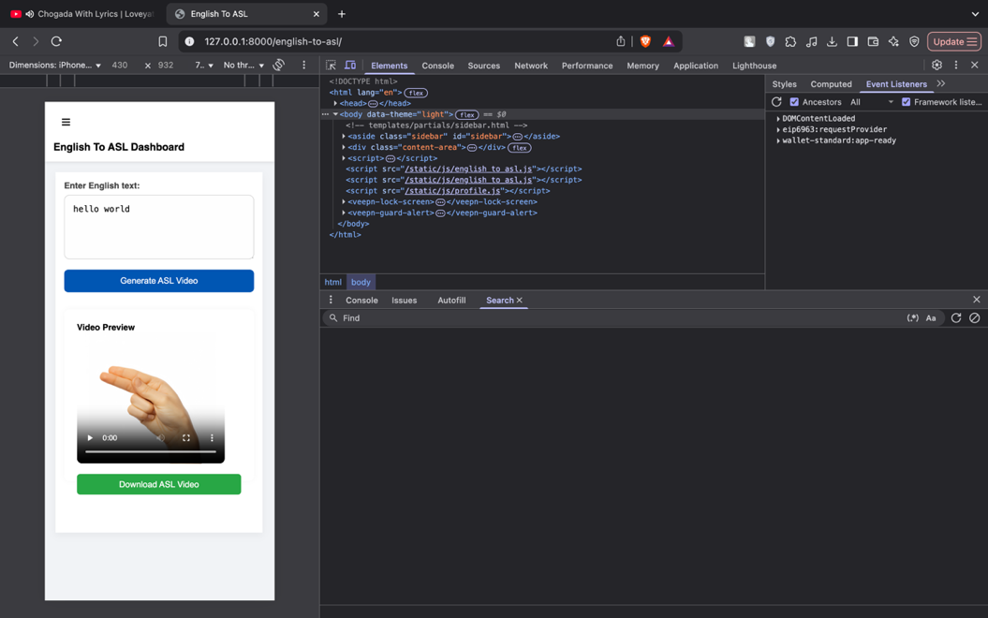

*Fig – 29: English-to-ASL Dashboard Responsive & Theme Assistance*

The dashboard adapts seamlessly throughout devices and attempts dark/light theme toggling, confirming comprehensive responsiveness and user-friendly interface customization for enhanced accessibility and usability.

1. **Real-World Usages of the ASL Translation System**

The attention-augmented LSTM ASL translation system—competent of bidirectional gesture‐to‐text and text‐to‐gesture transformation—attempts transformative potential throughout multiple real-life domains. Here we highlight predominant application areas that leverage its real-time recognition, sentence production, and video synthesis capabilities.

1. **Assistive Communication for the Deaf and Hard-of-Hearing:**

In one of its practically direct usages, the ASL translation system can serve as a bridge betwixt Deaf users and hearing interlocutors. Throughout face-to-face conversations, the real-time gesture prediction dashboard (Segment 5.4) can capture a Deaf user’s signing through webcam, convert the top-ranked gestures into English words or phrases, and display them promptly on a tablet or smart display. Conversely, hearing individuals can type or speak in English, triggering the English-to-ASL video generator (Segment 5.5) to produce a short ASL animation that the Deaf user can view. This bidirectional flow restores conversational fluidity in classrooms, customer-service counters, medical consultations, and everyday social interactions.

1. **Educational Tools and Self-Mastering Platforms:**

Language learners and interpreters can benefit out of a self-paced ASL tutoring application. By feeding prerecorded gesture sequences or typing English vocabulary, students receive instantaneous feedback: the system’s per-class precision and recall charts (Figure 7) escort learners to refine handshape accuracy, while the sentence production module furnishes contextually correct English equivalents. Additionally, the generated ASL videos can be downloaded for offline practice or embedded into interactive e-mastering content.

1. **Tele-health and Remote Counseling:**

In telemedicine or tele-therapy scenarios, clinicians often face communication barriers when treating Deaf patients. Incorporating the ASL translation API into video-conferencing platforms empowers live translation of patient-signed medical histories and questions, while clinician instructions can be relinquished into ASL videos. The audit-logging tables (Segment 5.6) assure that entire medical interactions are traceable and compliant with privacy regulations.

1. **Generic Service Pavilions and Smart Signage:**

Airports, government offices, and transportation hubs can deploy touch-screen pavilions equipped with the translation system. Visitors intake queries—such as “Where is Gate A12?”—and receive a localized ASL video escort. Conversely, Deaf travelers signing “Where is baggage claim?” get an on-screen transcript. The featherlight image-to-video pipeline (Segment 5.5) guarantees beneath-one-consecutive production, assuring user engagement in high-throughput environments.

1. **Broadcasting and Live Events:**

Live news and sporting events can stream simultaneous ASL interpretation without human interpreters on-site. By mounting a camera on the event floor, the translation engine processes and overlays predicted sign labels in real time. For pre-scripted segments—like generic service announcements—the text-to-video generator creates high-quality ASL overlays that broadcasters can cue seamlessly.

1. **Incorporation with Wearables and Mobile Apps:**

Embedding the gesture prediction model into smartphones or AR glasses empowers on-the-go translation. A Deaf user wearing AR glasses could see English subtitles superposed on a hearing person’s face as they sign, while a hearing user could receive ASL video prompts for smooth commands (“Turn on the lights”) in smart-home usages.

1. **Research and Data Collection:**

Ultimately, the audit logs and rich metadata stowed in tables like **asl_aslprediction** and **asl_auditlog** (Segment 5.6) shape a valuable corpus for linguistic and usability research. Scholars can analyze which gestures incur the highest error rates or study gesture dynamics in different lighting conditions, driving subsequent breakthroughs in model vigorousness.

Broadly, these real-world usages demonstrate how an assimilated ASL translation system can enhance accessibility, education, generic engagement, and service delivery—ushering in a farther panoramic, connected society.

1. **Conclusion**

The “Unraveling the Silence: AI and Computer Vision Driven Sign Language Translation System” successfully demonstrates how modernistic deep-mastering and hand-tracing technologies can empower Deaf and hard-of-hearing users to interact farther wholly with the hearing world. By fusing a carefully deliberate attention-augmented LSTM model (Segment 5.1) with MediaPipe landmark extraction and real-time augmentation, our system accomplishes atop 99 % test‐constitute accuracy in classifying 36 distinct ASL gestures (Figure 3), while maintaining robust calibration (Figure 7) and near‐perfect separability in one-vs-rest ROC analysis (Figure 8). These results underscore the model’s dependability and its suitability for deployment on resource-constrained devices.

Beyond gesture recognition, the system furnishes a comprehensive bidirectional pipeline (Sections 5.4 & 5.5) that translates live gestures into English text or speech and transforms typed English into downloadable ASL videos. Audit-logging tables (Figures 11 & 12) assure that every prediction and sentence production event is traceable, facilitating performance monitoring and compliance with privacy standards. The user- and admin-centric UIs, captured in our utilized-case diagrams (Figures 13–15), demonstrate clear interaction flows: users can register, verify their email, and then access prediction and translation dashboards, while administrators retain comprehensive oversight of user histories and system logs.

In real-world contexts, this system can theatric improve accessibility in educational environments—where students and teachers can communicate through live captioning or tutoring playlists—and in healthcare, where remote consultations with Deaf patients require precise, low-latency interpretation. Generic‐service pavilions, broadcast overlays, and mobile AR incorporations farther expand its reach, turning any webcam-equipped device into a two-way translator (Segment 5.8).

Methodologically, the project adhered to an Agile, iterative progression procedure (Segment 4), enabling swift prototyping of mecca components—hand tracing, sequence modeling, text-to-speech, and video assembly—while continuously enhancing performance amid user feedback and quantitative criterion (Segment 5.1). The modular architecture permits subsequent extensions such as assistance for dynamic sentence syntax, additional sign languages, or transformer-based sequence models, without disrupting the existent codebase.

Despite its strengths, certain confines remain. The current video-production module relies on stationary letter-mapping preferably than comprehensive signer animations, which can limit expressiveness for idiomatic phrases. Additionally, although the model addresses a broad vocabulary of common gestures, performance may degrade with very swift signing or occluded hands. Subsequent work will explore multimodal intakes—incorporating facial expressions and upper-body posture—and domain adaptation techniques to improve vigorousness beneath distinctive lighting and camera angles. Incorporating a larger, farther contrasted dataset and experimenting with featherlight transformer encoders could farther raise accuracy and top-3 recall.

In conclusion, this project bridges a captious communication divide by harnessing state-of-the-art AI and computer vision to deliver an end-to-end ASL translation platform. Its high classification performance, comprehensive workflow automation, and user-engrossed design position it as a pragmatic, scalable tool for nurturing inclusion in educational, medical, generic, and personal contexts. By making sign language both observable and audible, we take a significant measure toward a world where “unraveling the silence” means enabling everyone to be heard—and understood.

1. **Research Opportunities and Subsequent Directions**

Creating on the success of our attention‐augmented LSTM ASL translation system, several promising avenues for research and enhancement can propel both academic understanding and real‐world jolt. These opportunities gauge model architecture, data collection, multimodal amalgamation, deployment strategies, and user‐centered advancements.

**1.Multimodal Gesture Understanding:**

Current landmark‐exclusively intakes capture hand shape and movement but omit captious linguistic cues such as facial expressions and upper‐body posture, which convey grammar and affect in ASL. Subsequent research can integrate MediaPipe’s face‐mesh and pose‐estimation modules alongside hand landmarks, feeding a joint depiction into a hybrid transformer-LSTM or graph‐neural‐network architecture. Such multimodal amalgamation could theatric improve recognition of classifiers (hand‐shape morphemes) and non‐manual markers, yielding farther accurate translations of sophisticated sentences.

**2. Grammar and Continual Sentence Modeling:**

Our pipeline excels at word‐level translation but relies on external LLMs for sentence fluency. A research direction is to embed an end‐to‐end sequence‐to‐sequence model—potentially based on transformers with cross‐modal attention—that directly translates time‐series landmark patterns into target‐language text. Training such models requires aligned corpora of sign videos and sentence transcripts, intriguing efforts to curate large, richly annotated ASL corpora with sentence‐level alignment.

**3. Domain Adaptation and Personalization:**

Signers exhibit individual variations in speed, hand size, and signing style. Domain‐adaptive methods—such as adversarial training or meta‐mastering—can tailor the model to new speakers with minimal calibration data. Relatedly, one‐shot or few‐shot mastering techniques could enable swift personal adaptation, enhancing accuracy for users with unique signing patterns. Research into real‐time adaptation algorithms that update model weights on‐device without compromising privacy would be notably impactful.

**4. Featherlight and Edge Deployment:**

While our landmark‐based intake is already computationally potent, farther compression is feasible amid quantization, pruning, or knowledge distillation onto tiny transformer or LSTM architectures. Evaluating trade‐offs betwixt accuracy and latency on smartphones, AR glasses, and embedded boards will escort design of truly ubiquitous translation—where live interpretation happens locally, without cloud reliance.

1. **Evolved Video and Avatar Production:**

The current text‐to‐ASL video module pertains stationary image sequences for every letter. Subsequent work can explore neural relinquishing or parametric avatar systems that animate continual gestures, hand transitions, and non‐manual markers, producing farther natural and grammatically correct ASL videos. Neural radiance fields (NeRF) or motion‐capture‐driven deep mastering could enable photo‐realistic, customizable avatars for richer user engagement.

1. **Ethical, Privacy, and Accessibility Studies:**

As ASL data often characteristics identifiable individuals, privacy‐preserving techniques—such as landmark‐exclusively data collection and differential privacy—are pivotal. Research into user perceptions of automated translation accuracy, dependability, and social acceptance will assure ethical deployment. Participatory design studies with Deaf communities can uncover usability barriers and inform breakthroughs in user interfaces, consent flows, and error handling.

1. **Evaluation in Real‐World Contexts:**

Laboratory benchmarks furnish initial performance assessments, but real‐world trials in educational, healthcare, and generic‐service contexts will yield insights into system vigorousness beneath distinctive lighting, backgrounds, and network conditions. Designing standardized evaluation protocols and task‐based criterion (e.g., comprehension scores in interpreted conversations) will facilitate objective comparison throughout competing systems.

1. **Continual Mastering and Maintenance:**

Language evolves, and sign dialects differ throughout regions. Implementing lifelong mastering frameworks—whereby deployed models periodically retrain on anonymized user corrections—can tailor to changing vocabulary and local variants. Research into safe, automated data‐collection pipelines that incorporate user feedback while preserving confidentiality will keep the system current and accurate.

By pursuing these research directions, the ASL translation platform can evolve into a farther expressive, personalized, and ethically grounded tool—advancing accessibility, nurturing inclusion, and catalyzing innovation in sign‐language technology.

1. **BIBLIOGRAPHY**
2. ***Bauer, B., Swets, D.L., Weng, J.J. Friedrich, K.K., (2002) Towards an Automatic Sign Language Recognition System Utilizing Subunits. Springer Nature Link. [Online]. 2298, Available out of: <https://link.springer.com/chapter/10.1007/3-540-47873-6_7> [Accessed 31 Dec 2024].***
3. ***Cui, Y. , (1995) Mastering-based hand sign recognition utilizing SHOSLIF-M. IEEE. [Online]. 0 (10.1109/ICCV.1995.466879), pp. 0. Available out of: <https://ieeexplore.ieee.org/abstract/document/466879> [Accessed 31 Dec 2024].***
4. ***Kim, S., Waldrom, M.B. (1995) Isolated ASL sign recognition system for deaf persons. IEEE. [Online]. 3 (3), pp. 261 - 271. Available out of: <https://ieeexplore.ieee.org/abstract/document/413199> [Accessed 31 Dec 2024].***
5. ***Koller, O. (2015) Continual sign language recognition: Towards large vocabulary statistical recognition systems handling multiple signers. Computer Vision and Image Understanding. [Online]. 141, pp. 108-125. Available out of: <https://www.sciencedirect.com/science/article/abs/pii/S1077314215002088> [Accessed 31 Dec 2024].***
6. ***Kumar, P. Wadhawan, A****.****(2020) Deep mastering-based sign language recognition system for stationary gestures. S.I. : Hybrid Artificial Intelligence and Machine Mastering Tech. [Online]. 32 , pp. 7957–7968. Available out of: <https://link.springer.com/article/10.1007/s00521-019-04691-y#citeas> [Accessed 31 Dec 2024].***
7. ***Ouhyoung, M., Ling, R.H., (1998) A real-time continual gesture recognition system for sign language. IEEE. [Online]. pp. 10.1109/AFGR.1998.671007. Available out of: <https://ieeexplore.ieee.org/abstract/document/671007/authors#citations> [Accessed 31 Dec 2024].***
8. ***Wadhawan, A., Kumar, P. (2019) Sign Language Recognition Systems: A Decade Systematic Literature Retrospect. Springer Nature Link. [Online]. 28 , pp. 785–813. Available out of: <https://link.springer.com/article/10.1007/s11831-019-09384-2> [Accessed 31 Dec 2024].***
9. **Apendix**

**11.1Desktop UI Screenshots**

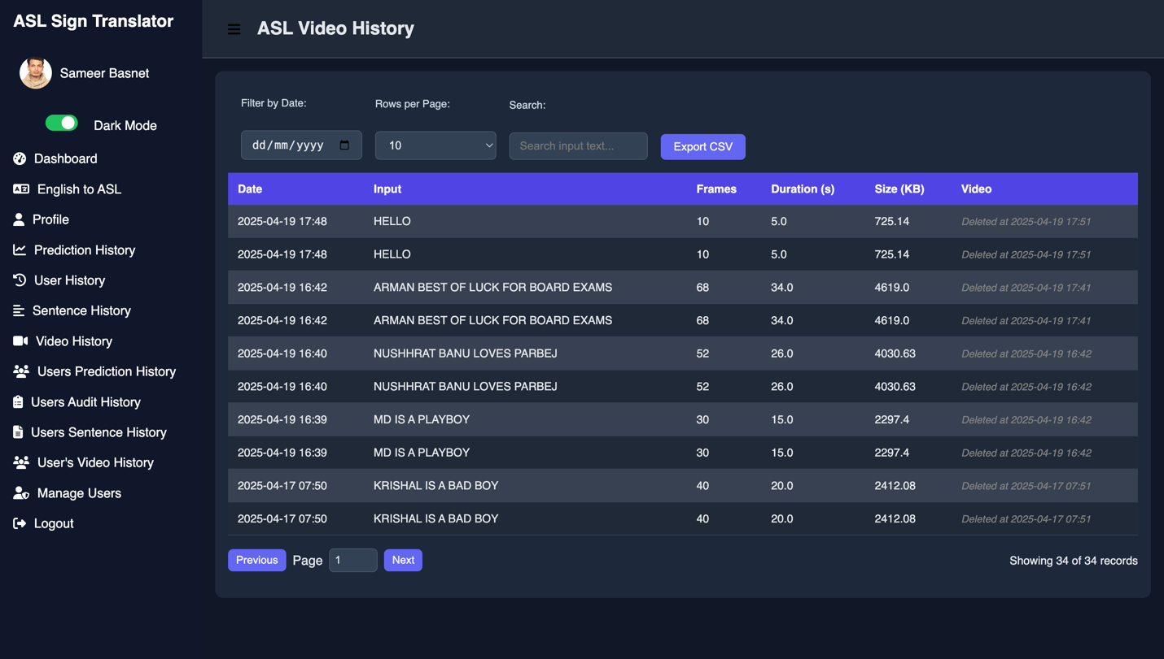

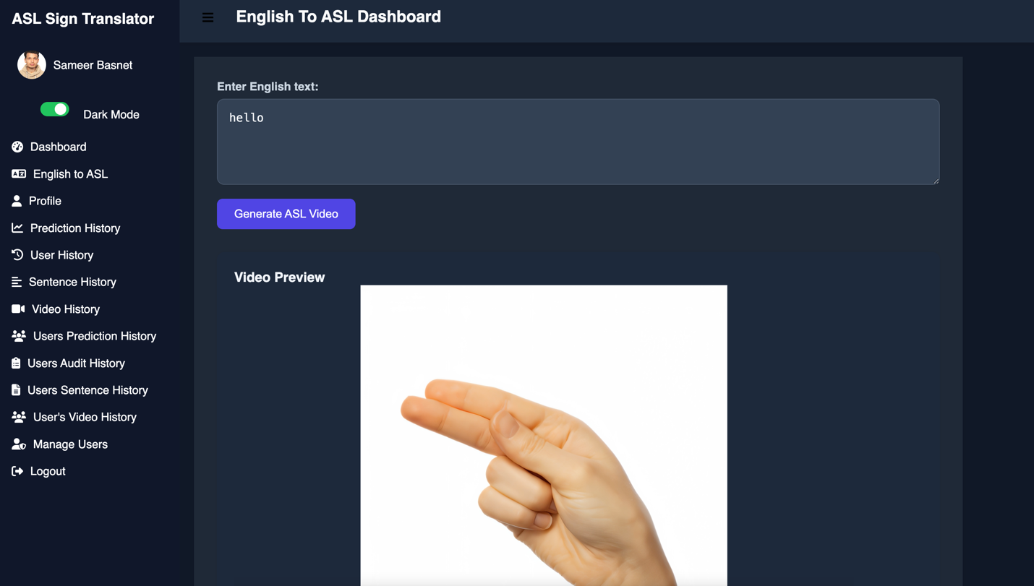

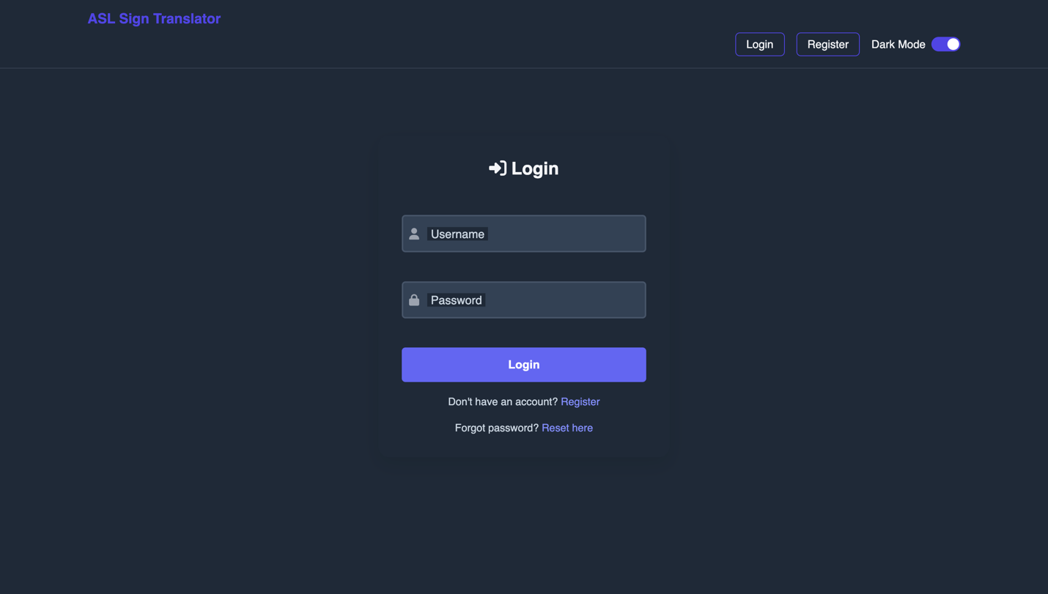

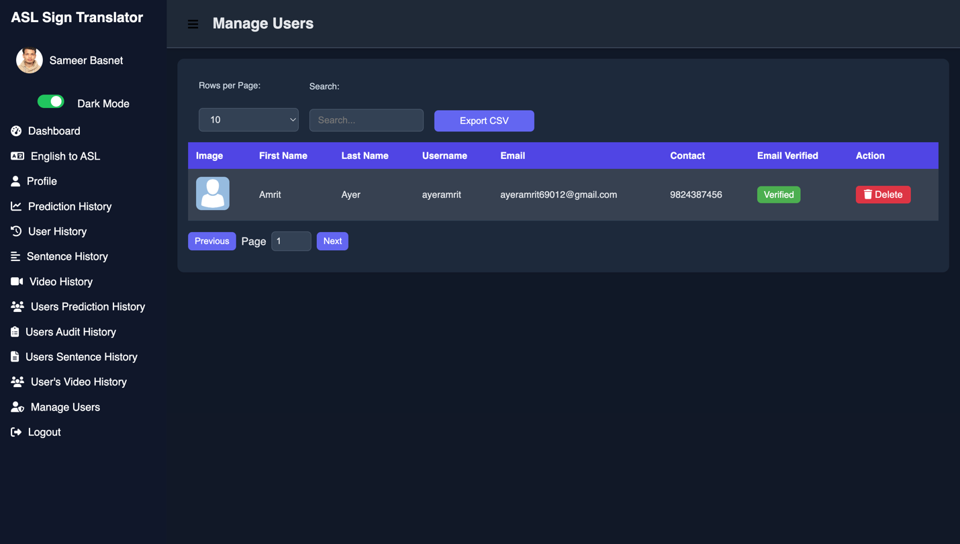

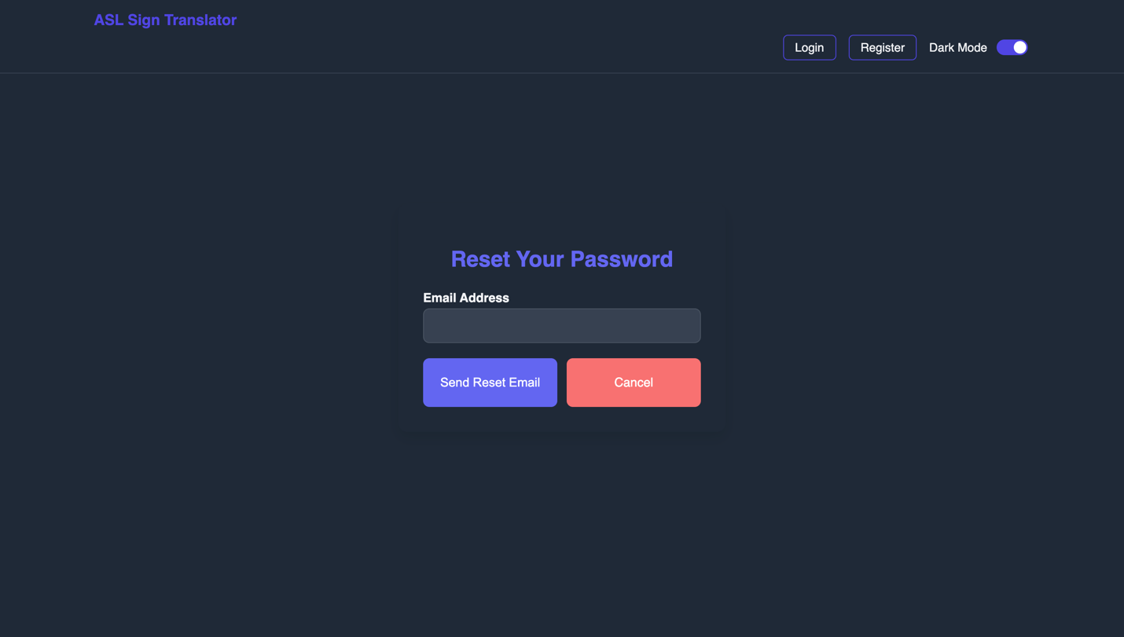

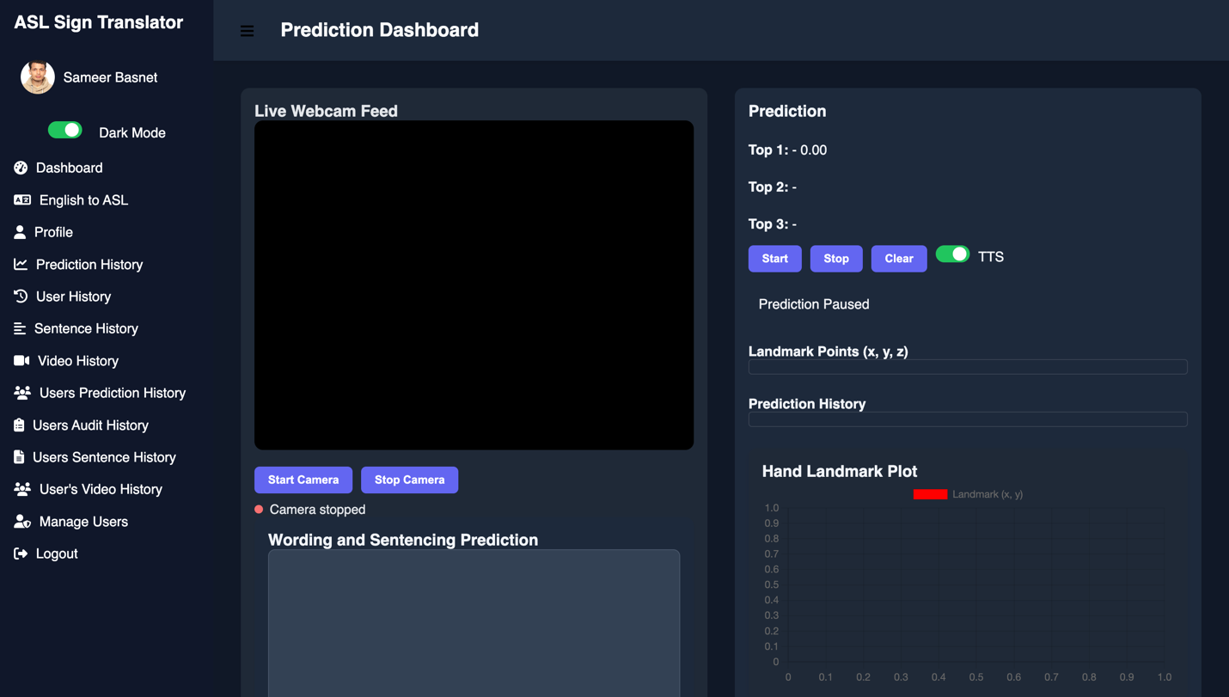

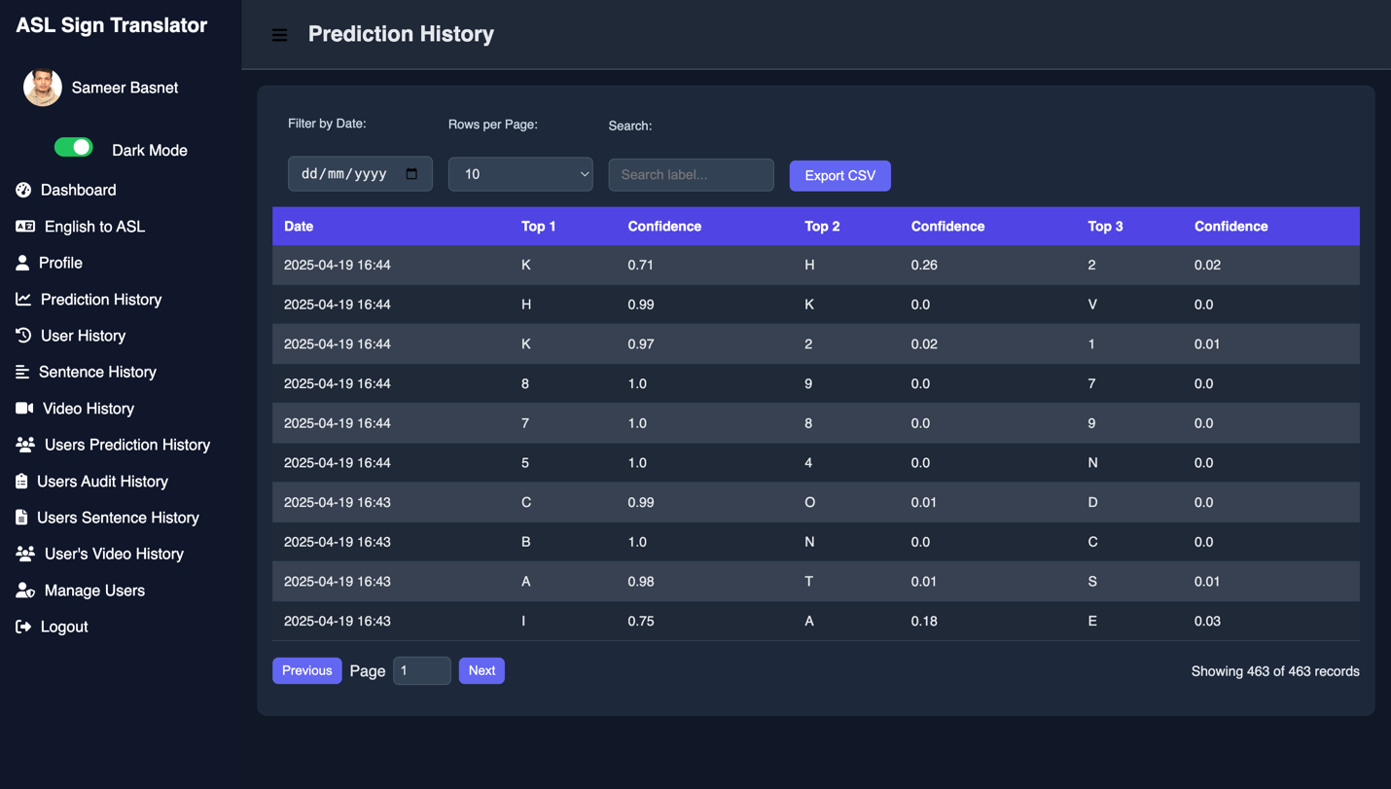

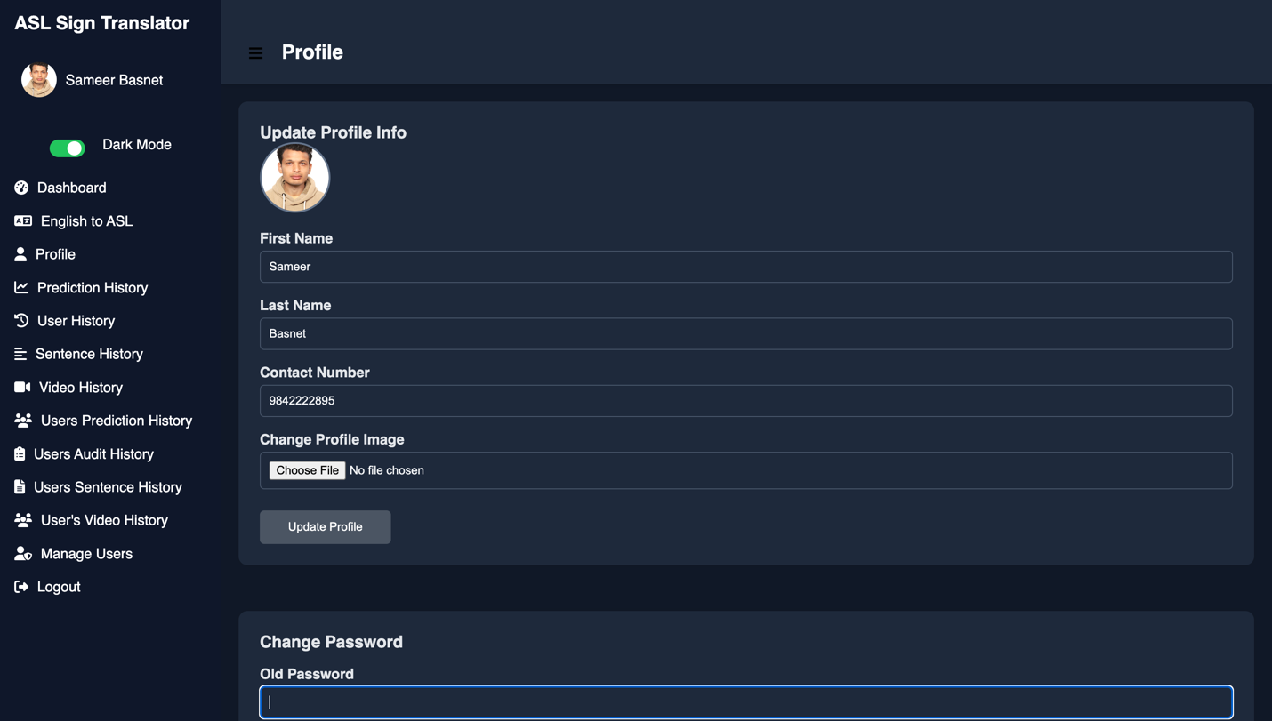

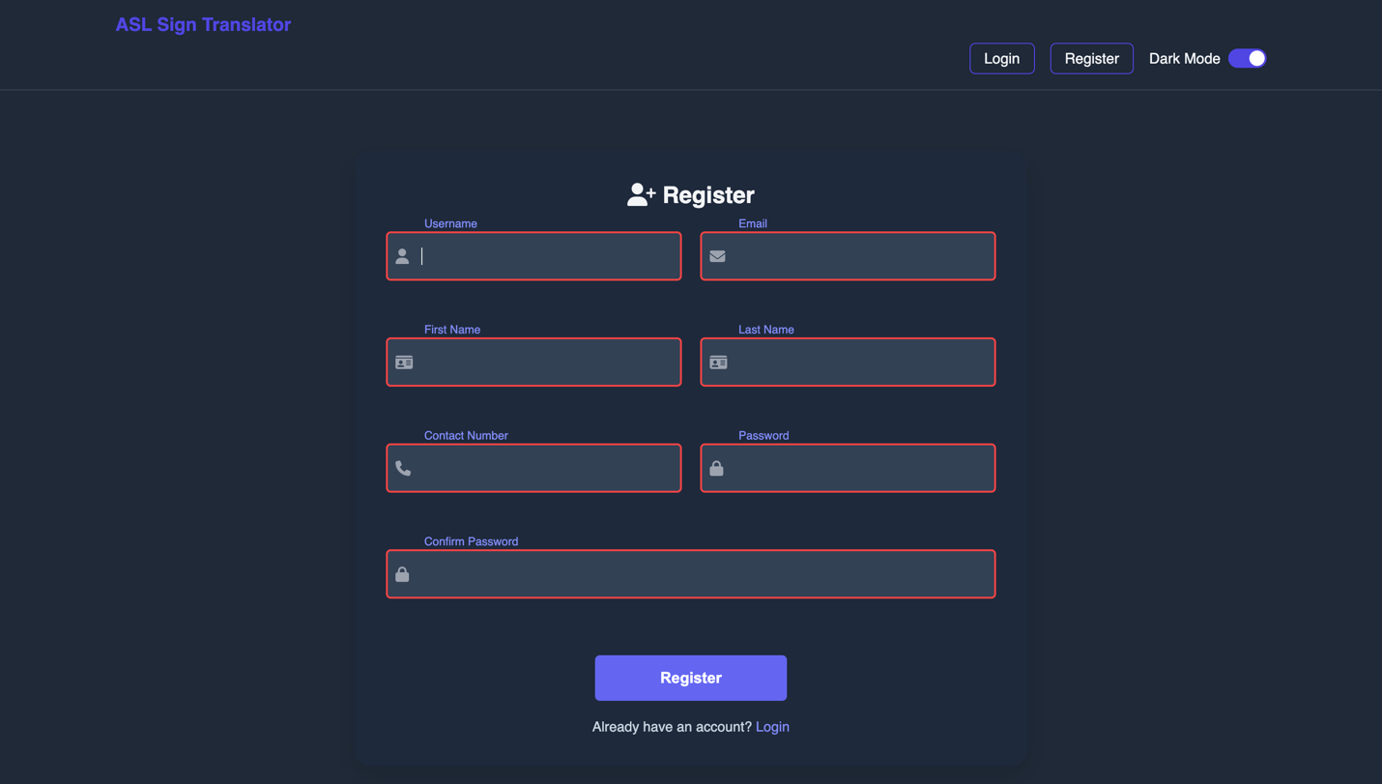

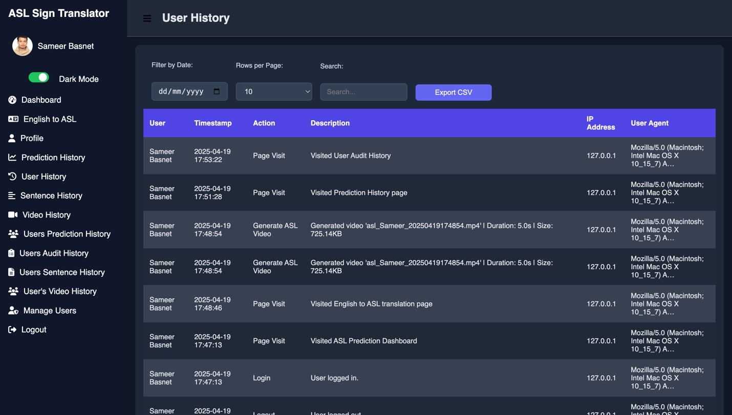

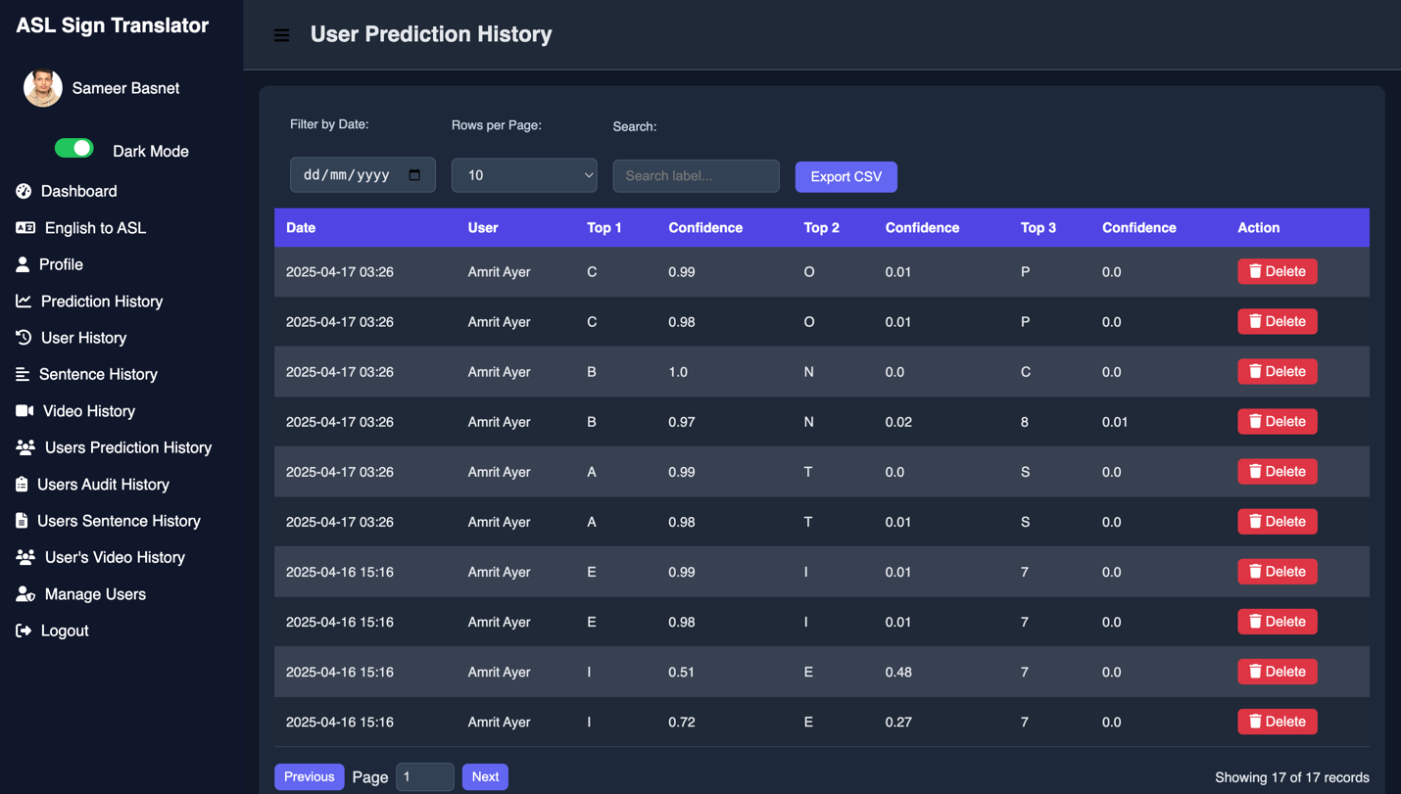

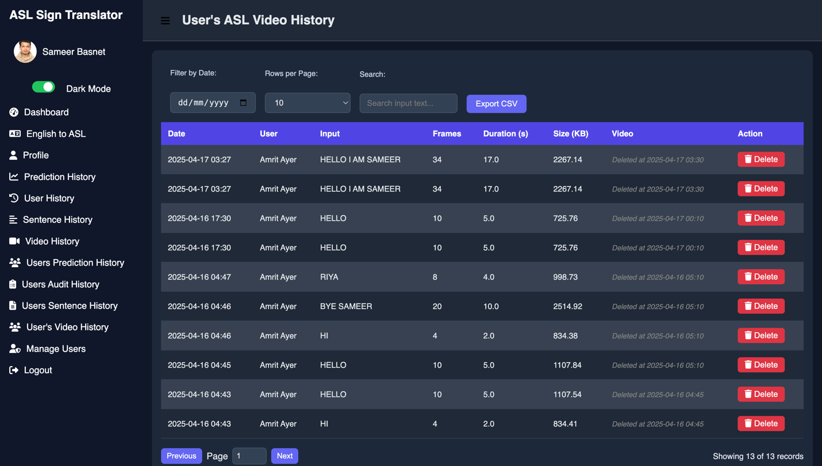

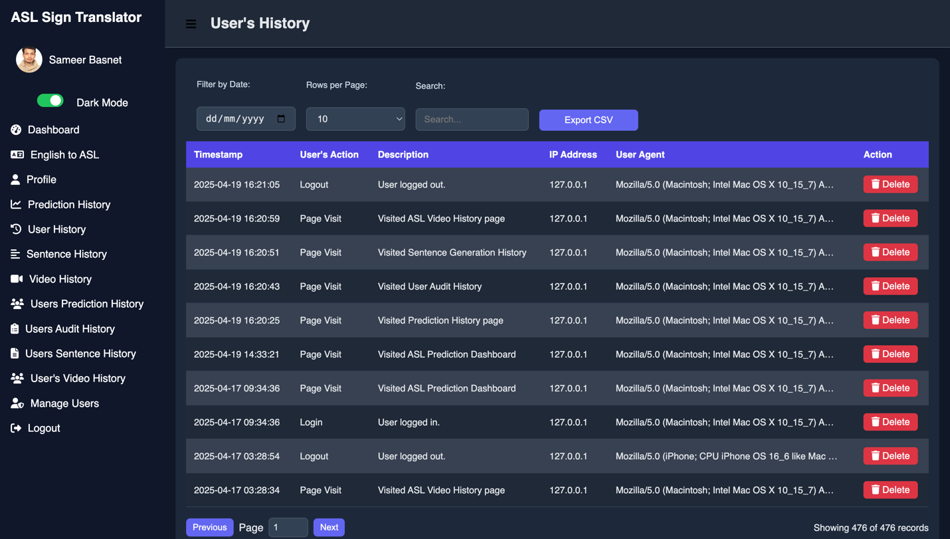

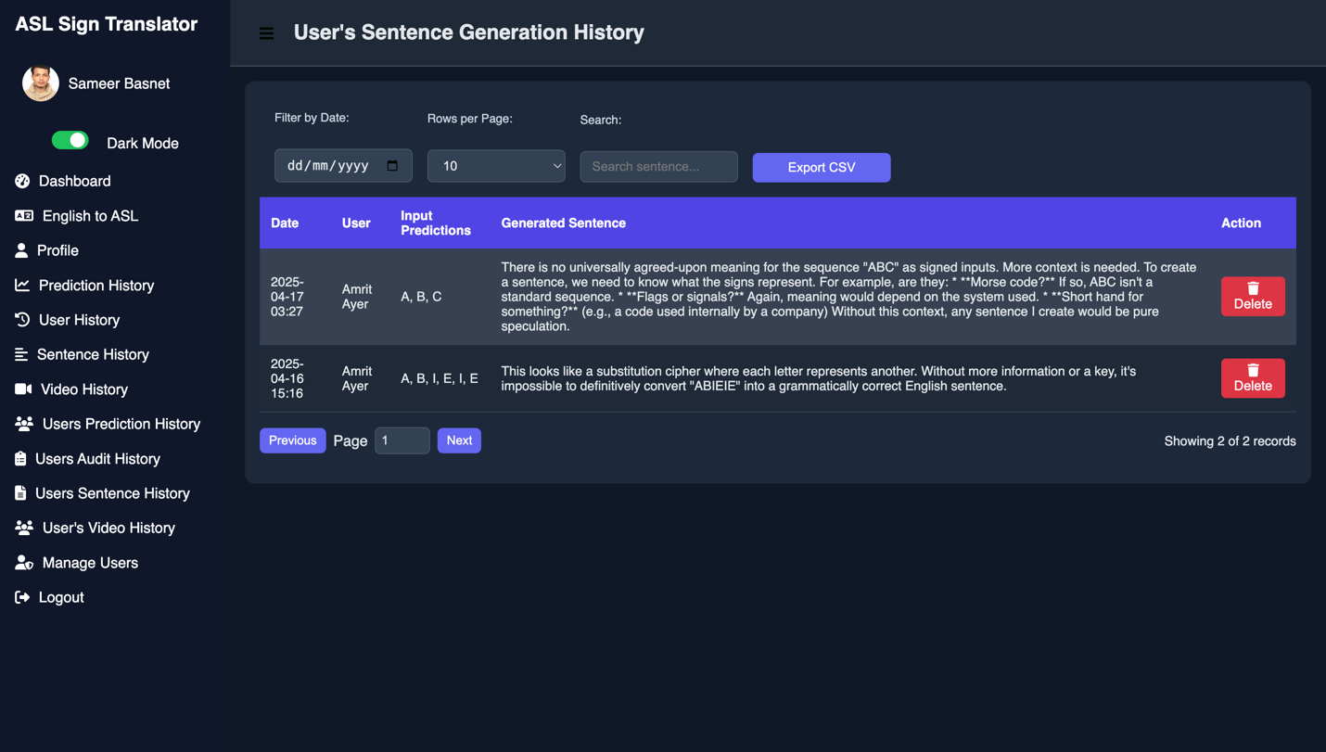

***11.2 Mobile UI Screens***

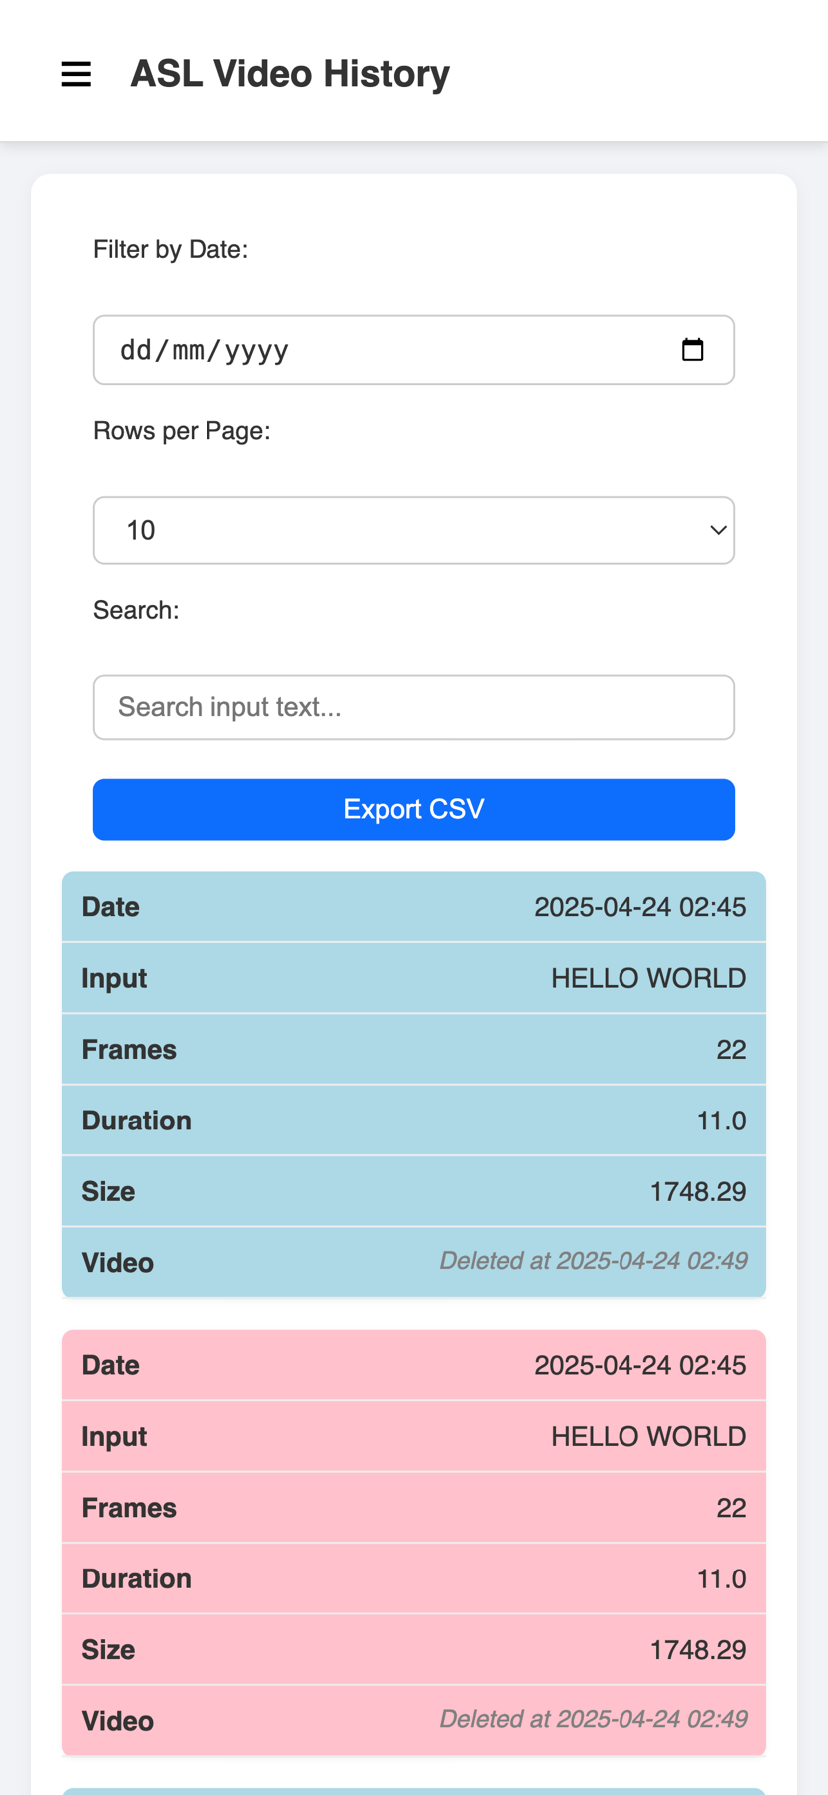

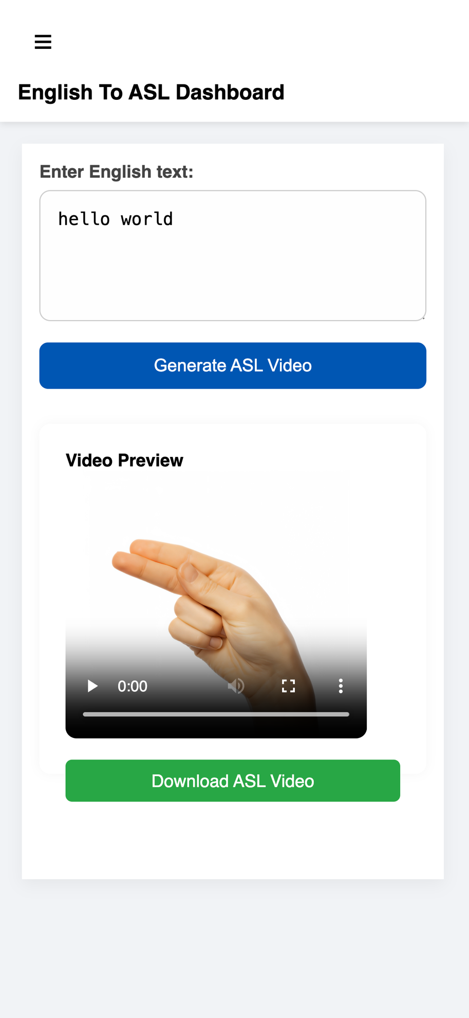

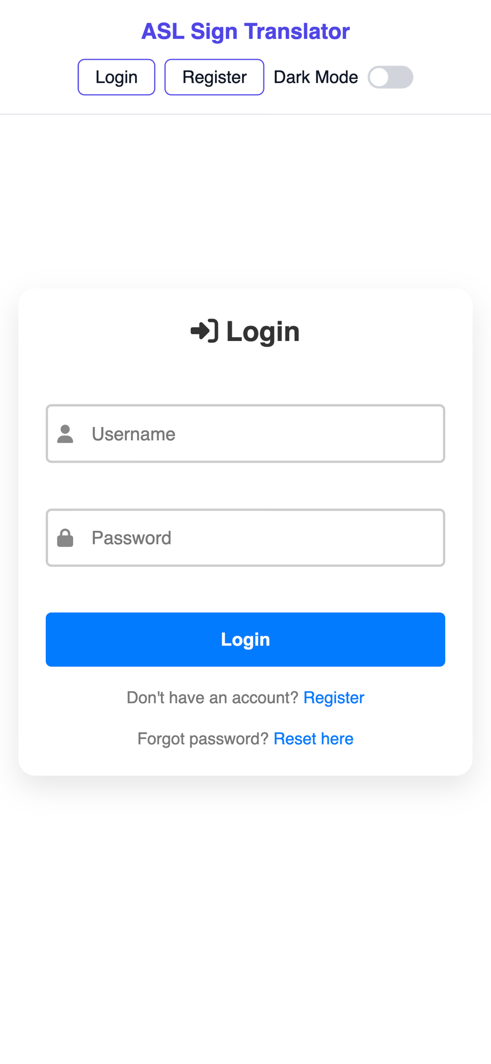

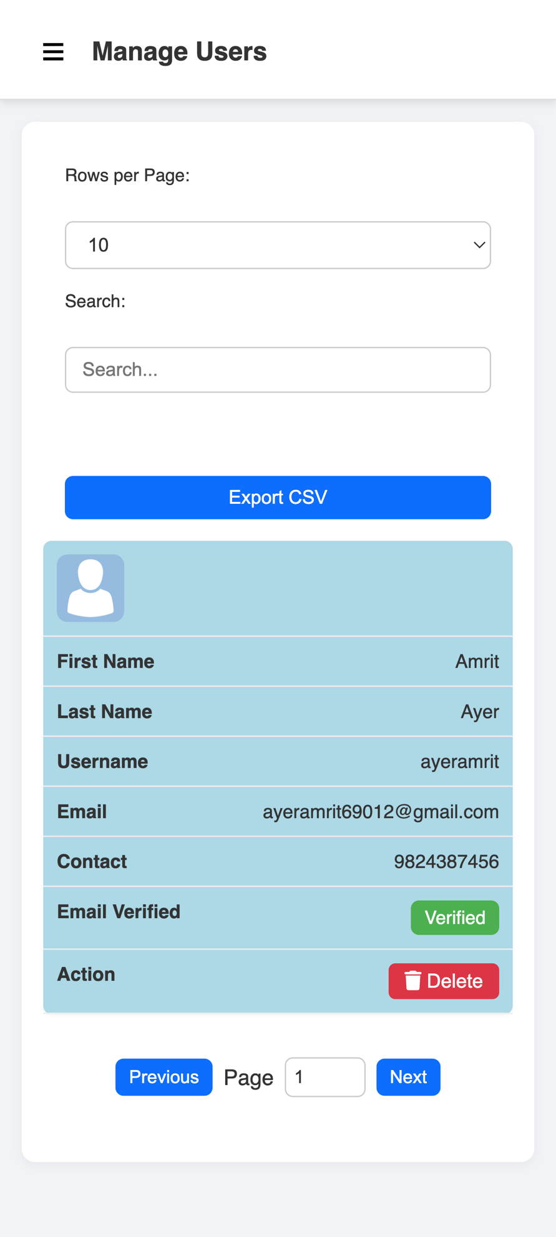

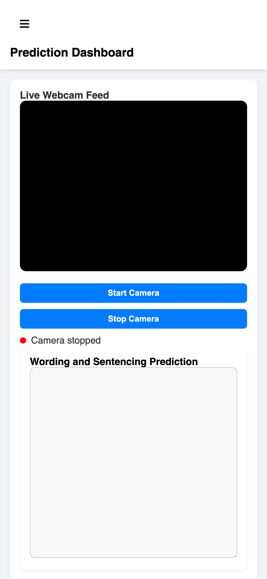

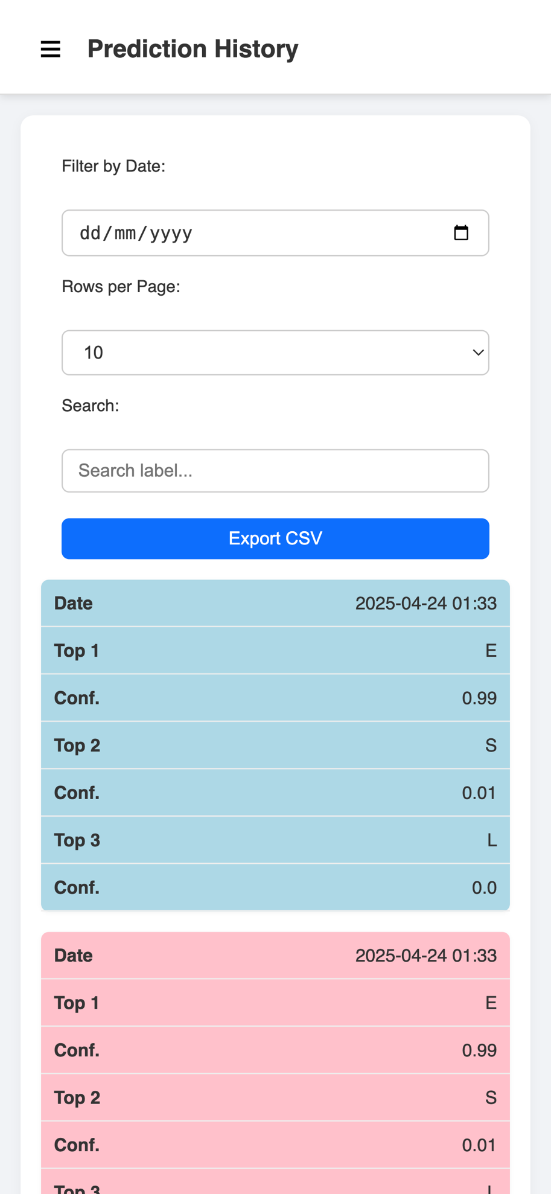

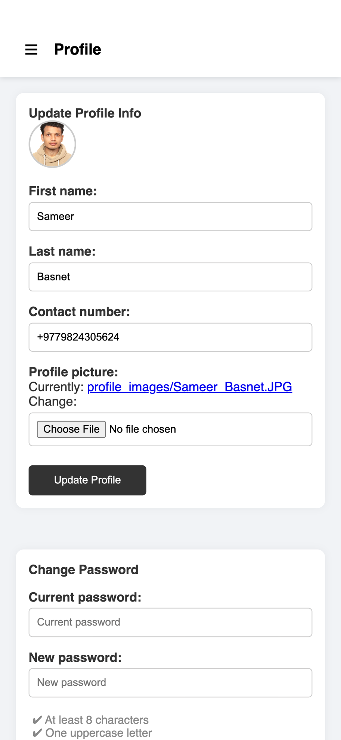

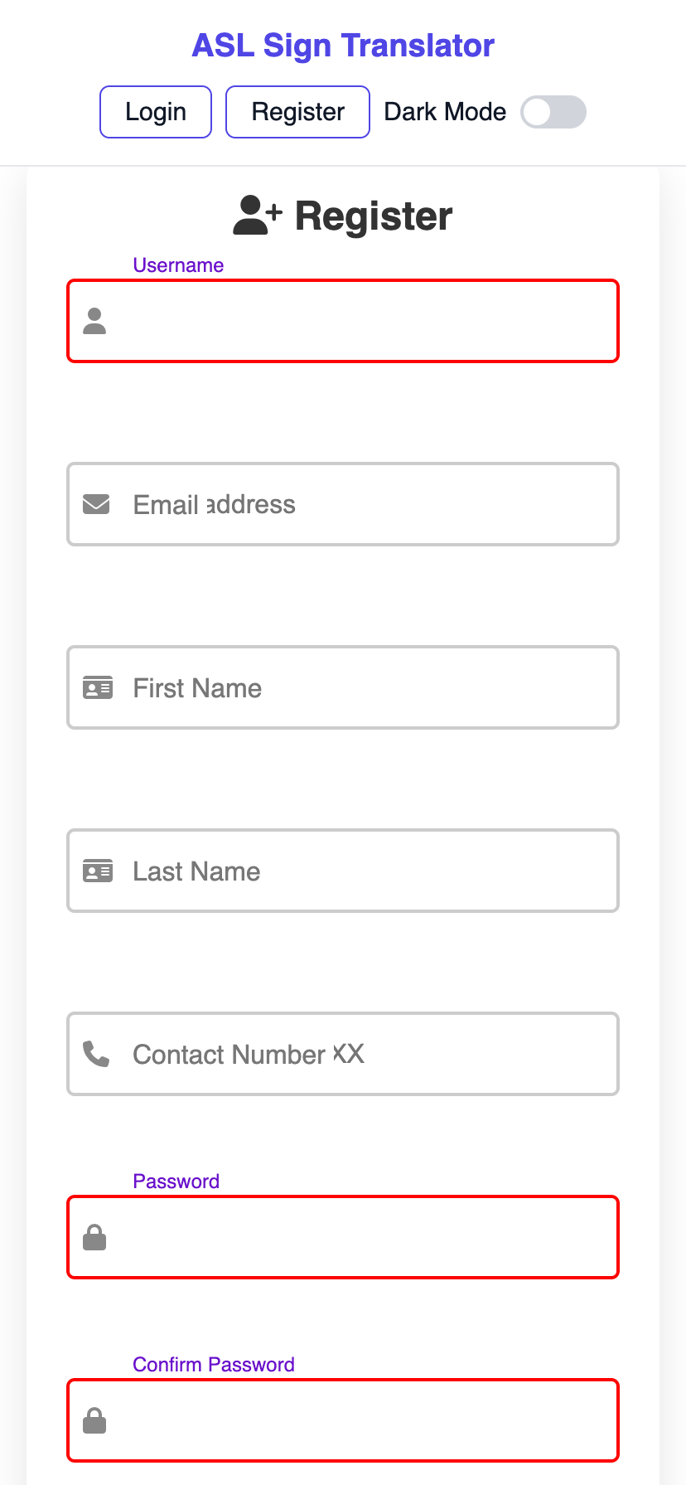

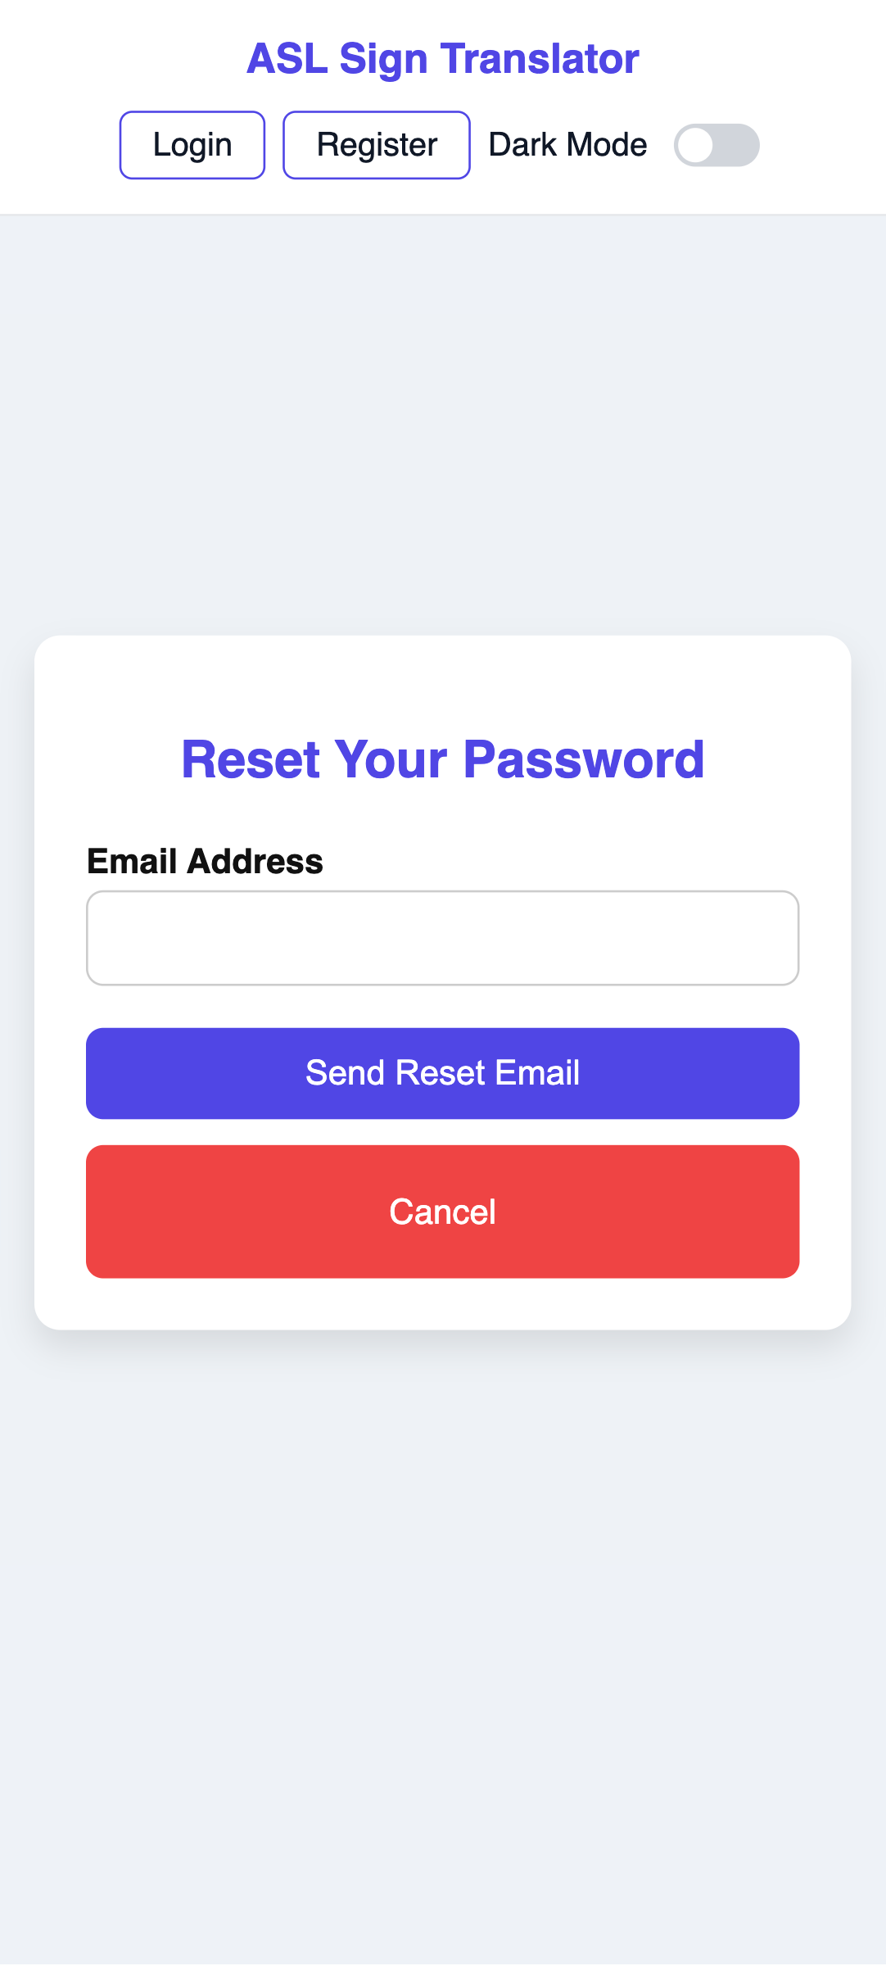

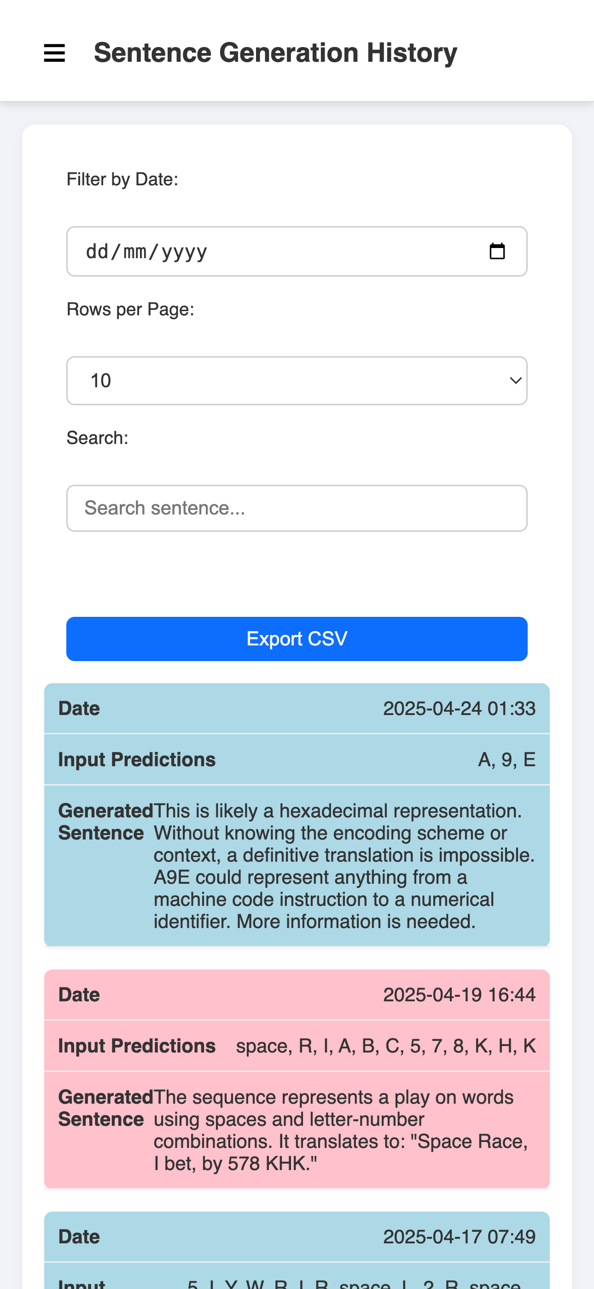

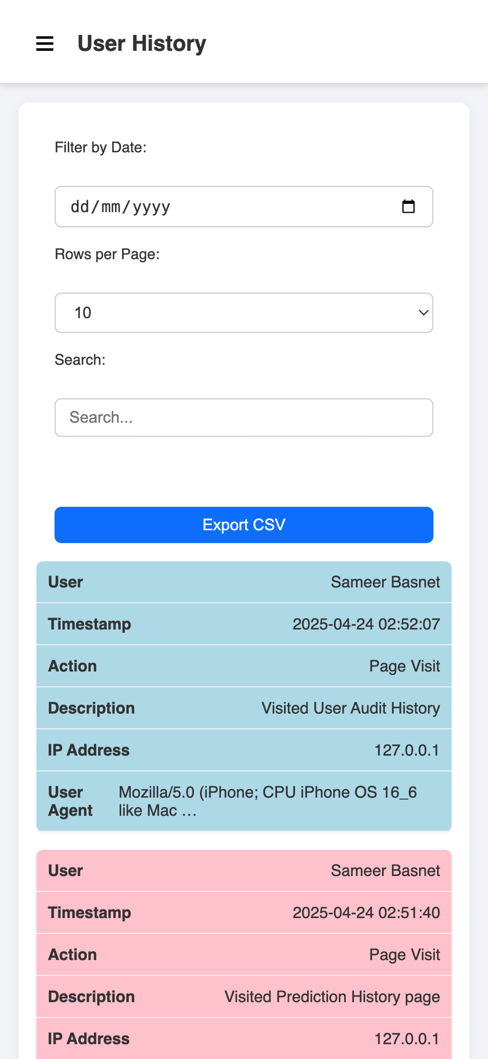

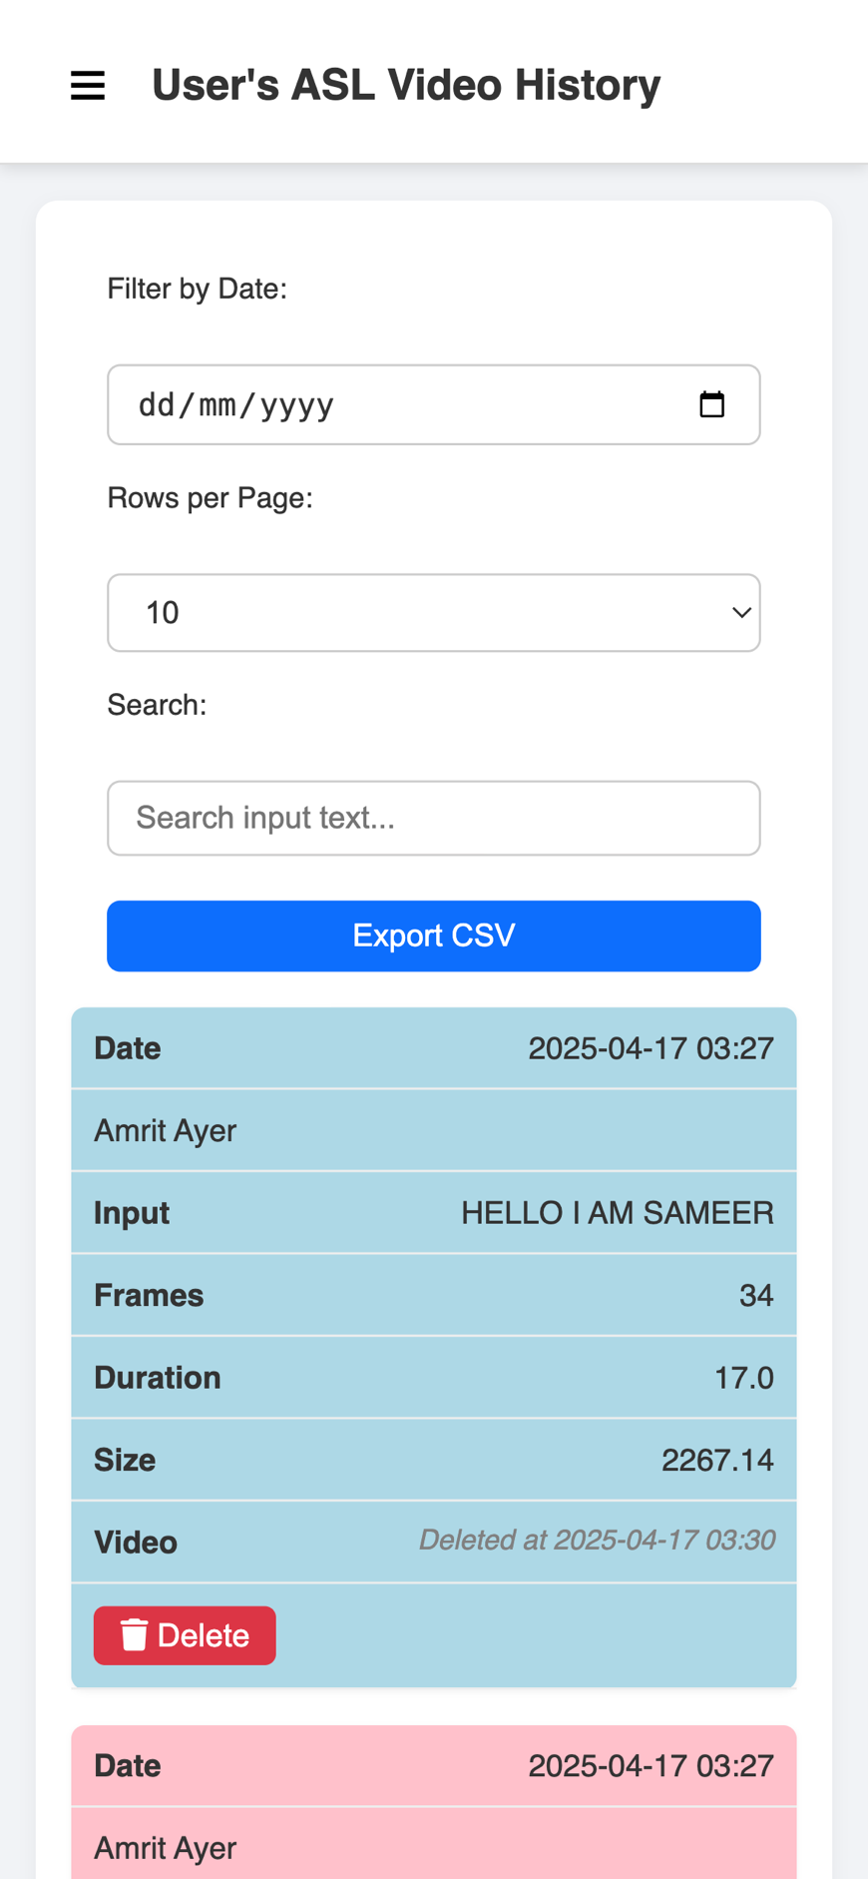

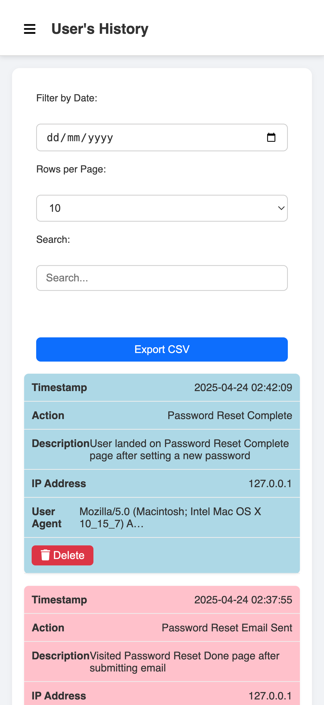

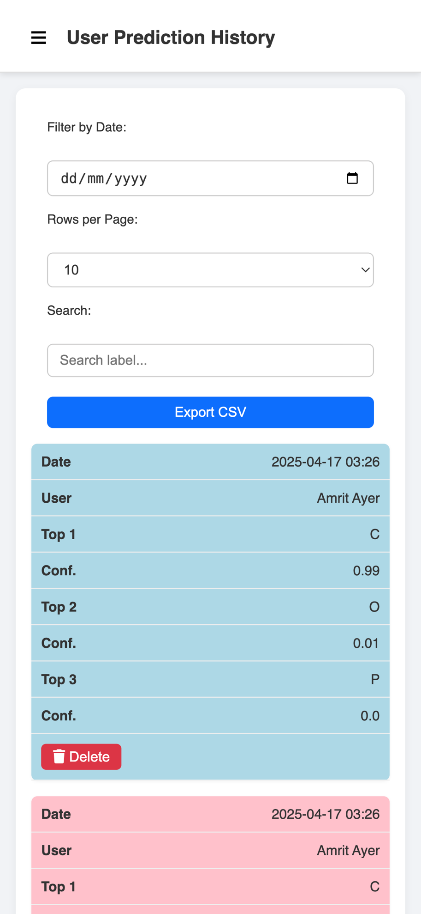

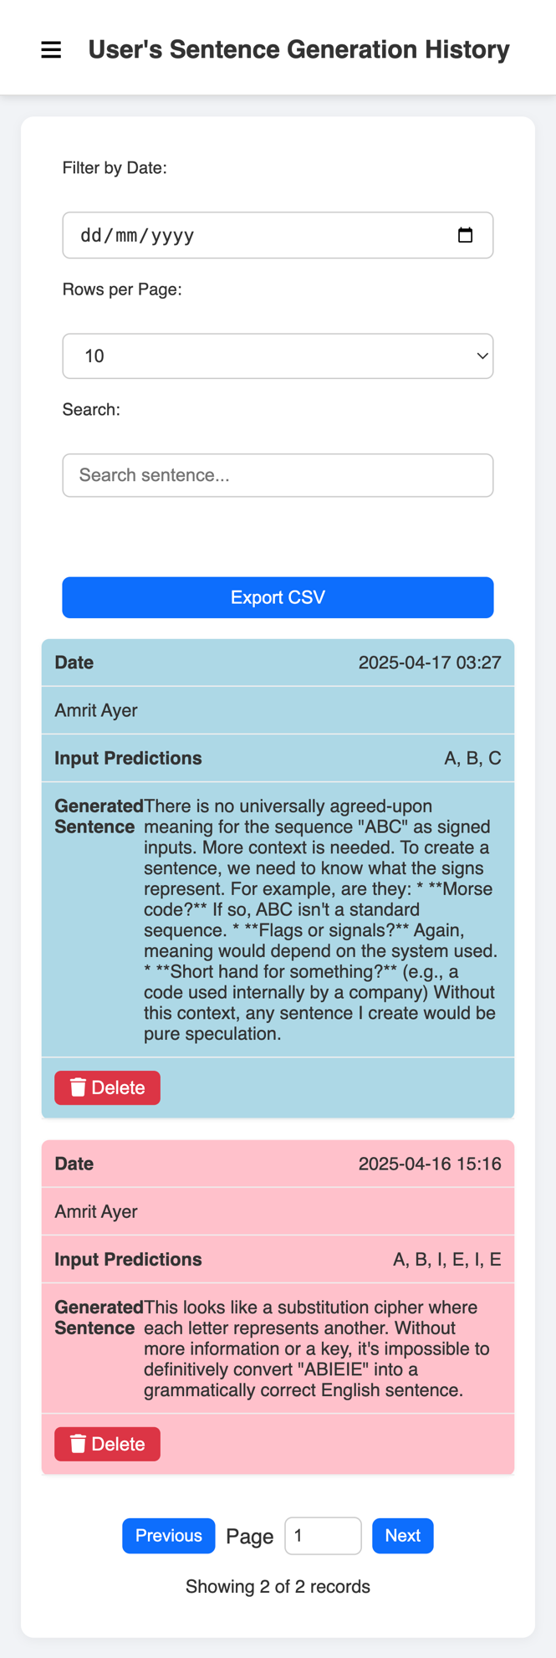

***11.3 Coding Screenshots***

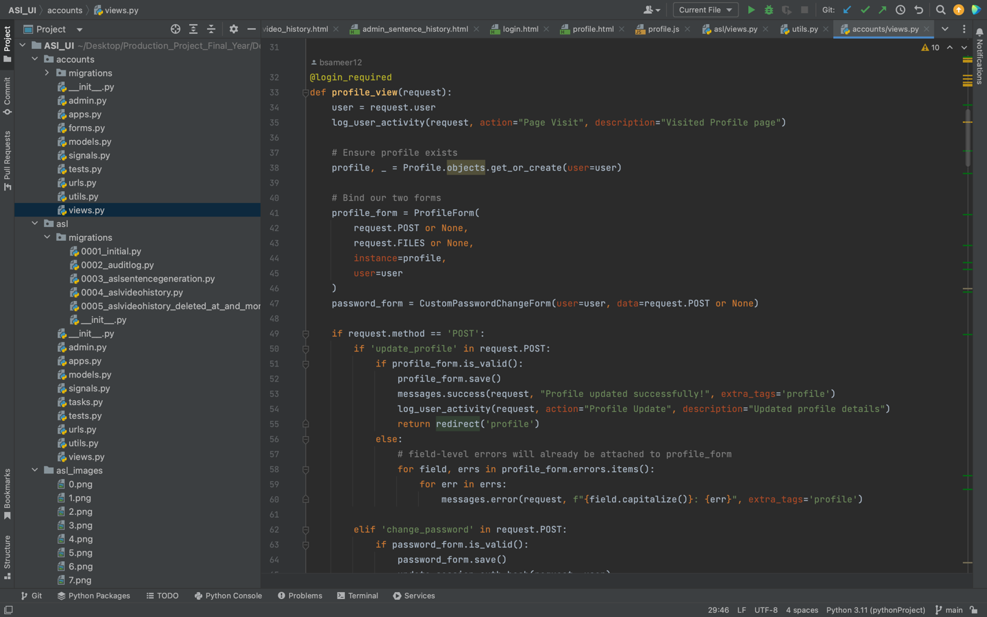

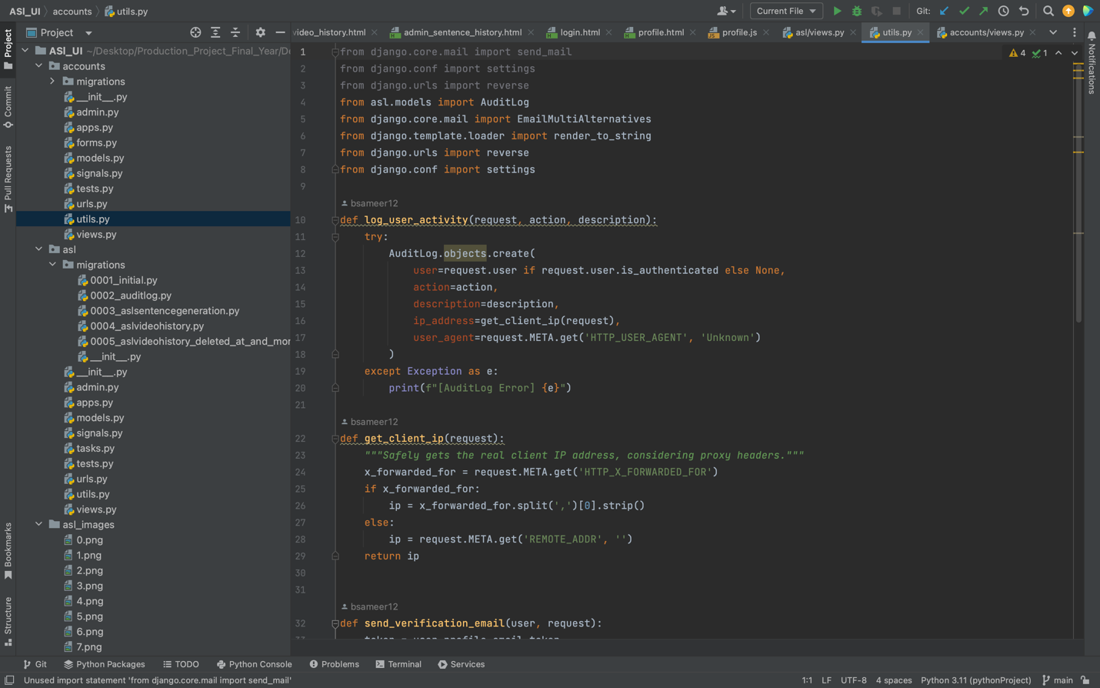

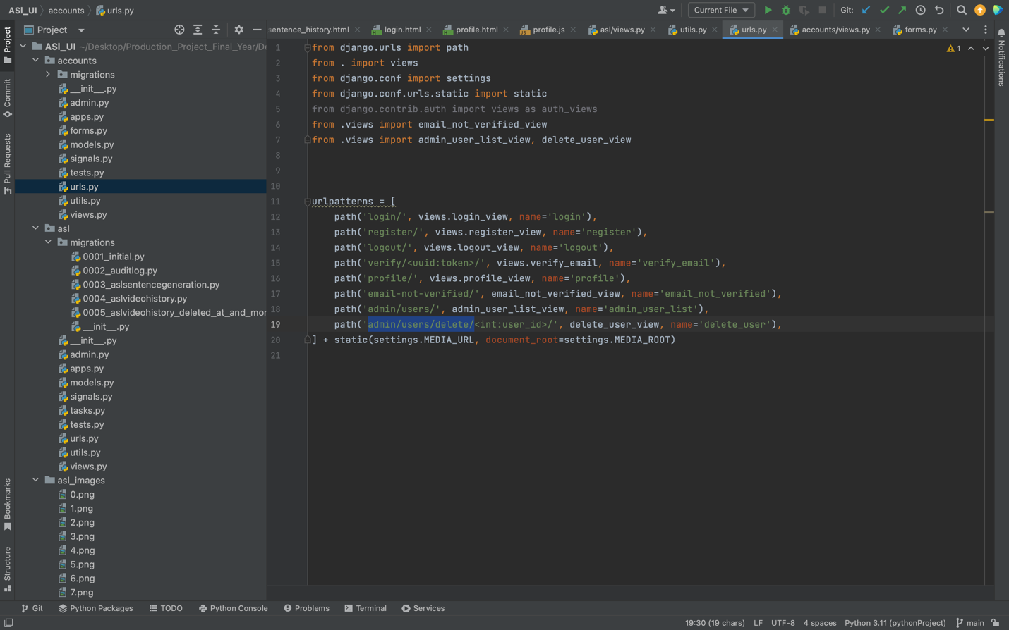

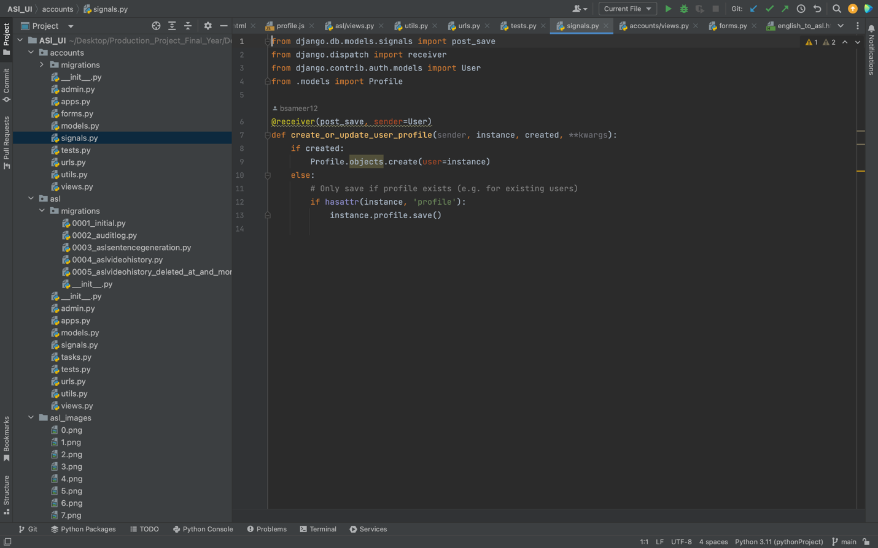

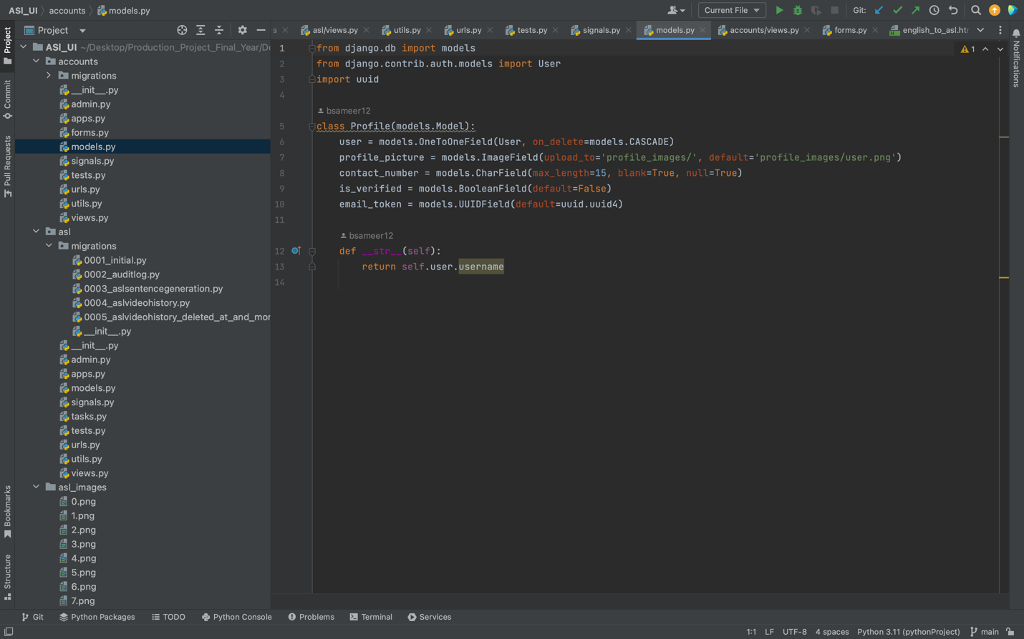

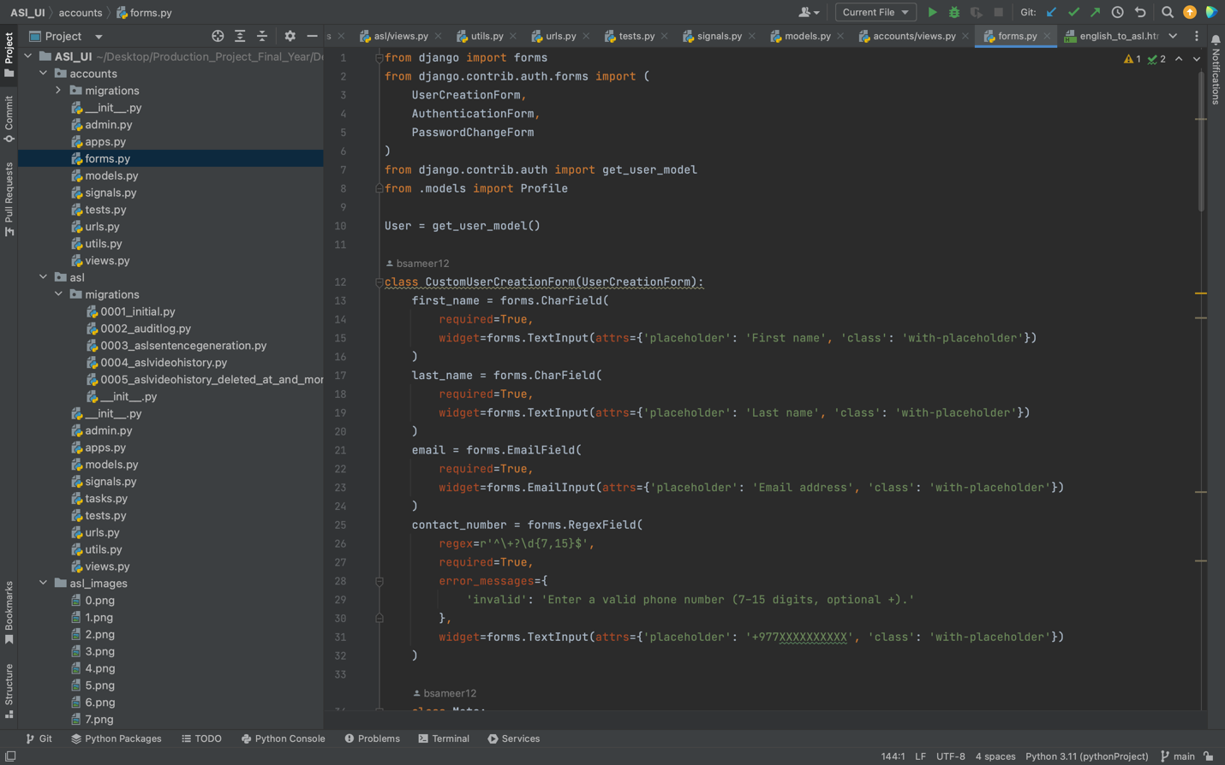

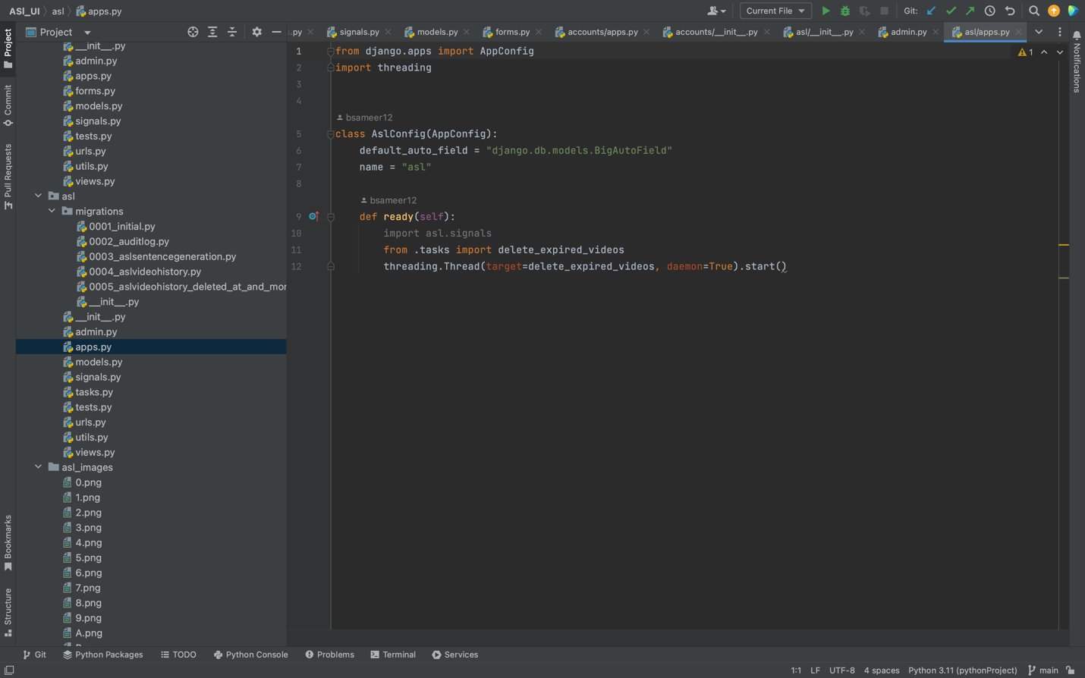

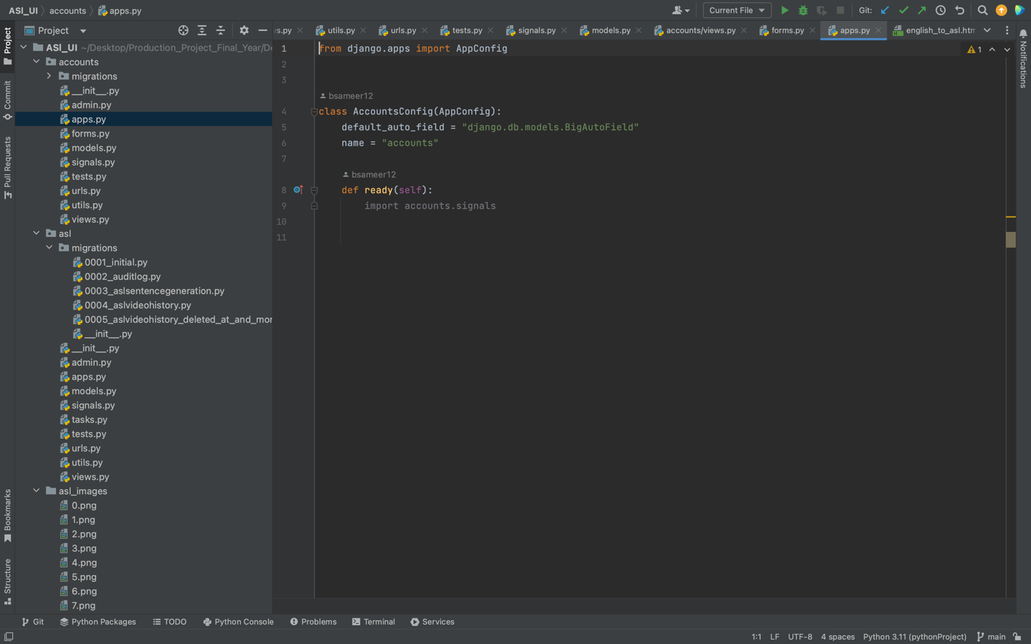

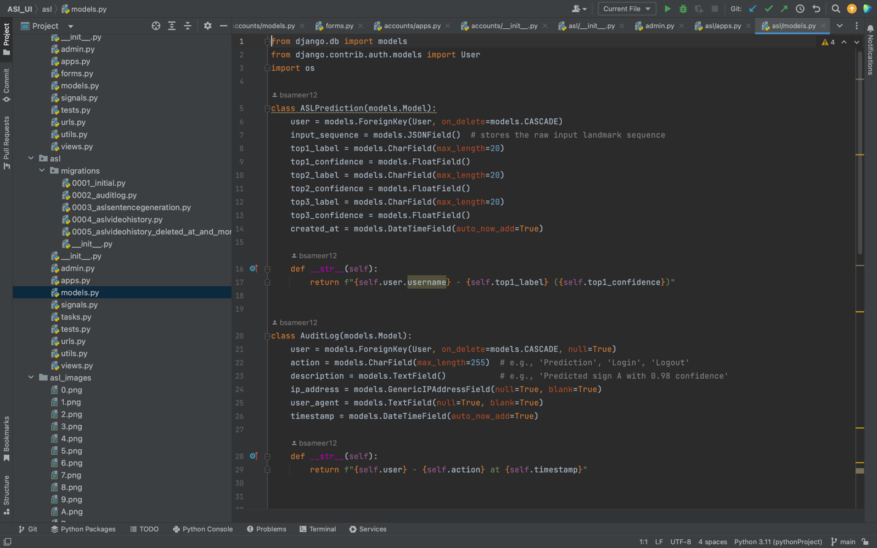

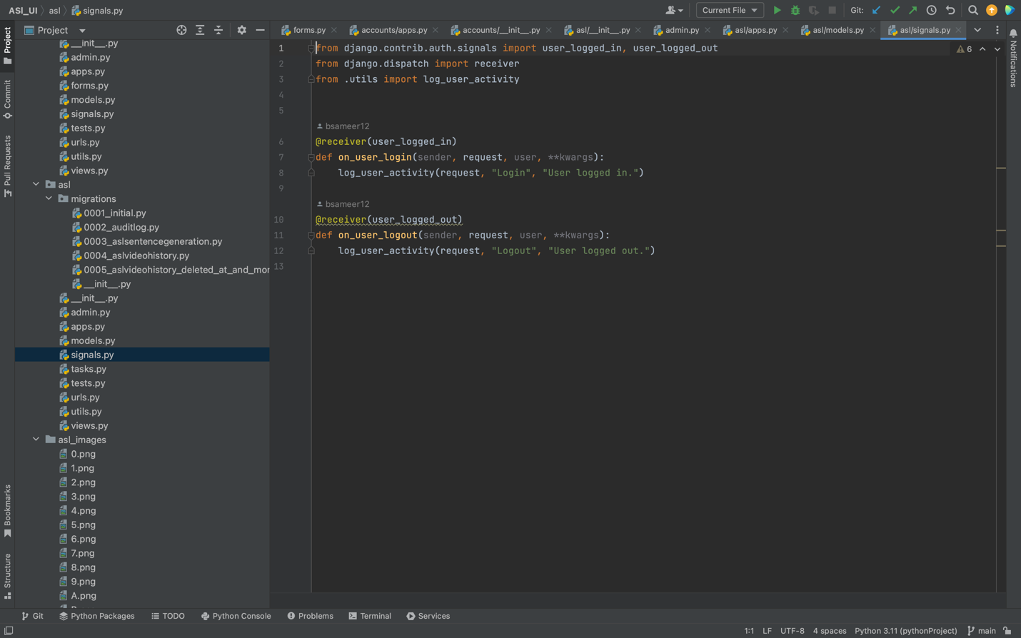

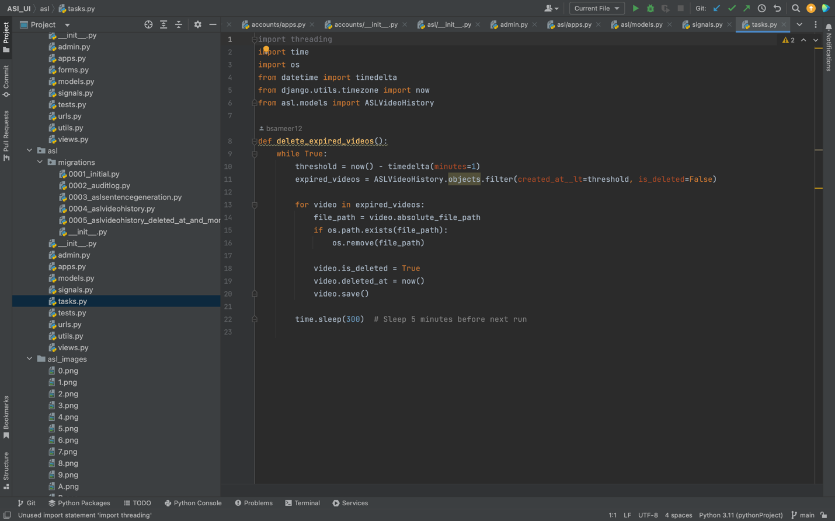

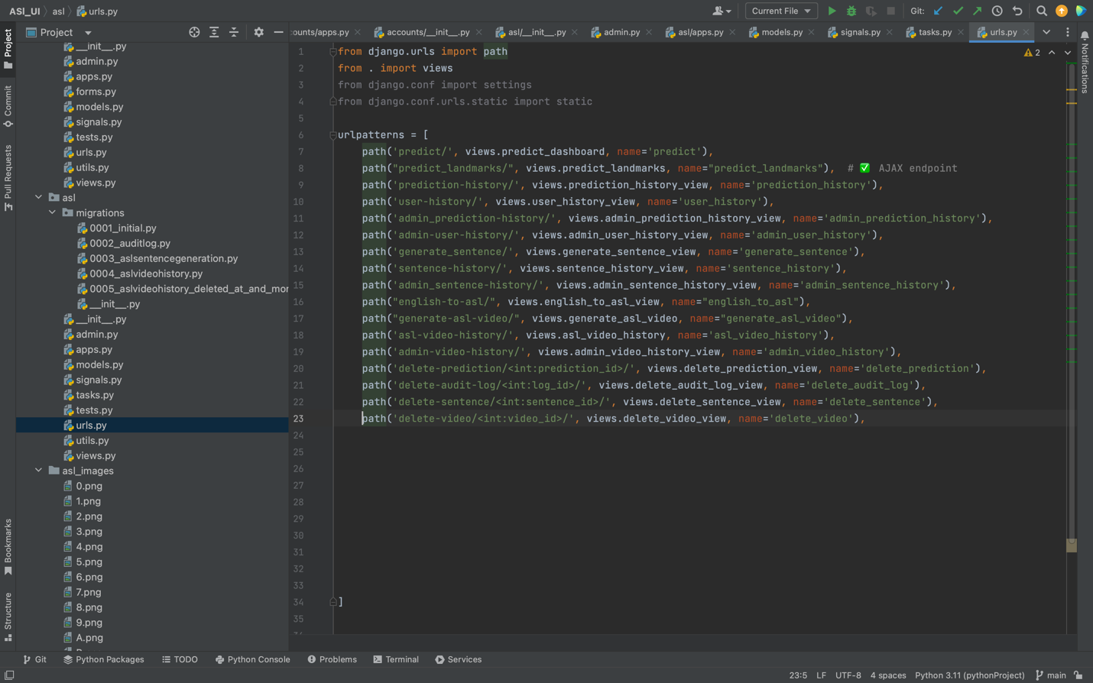

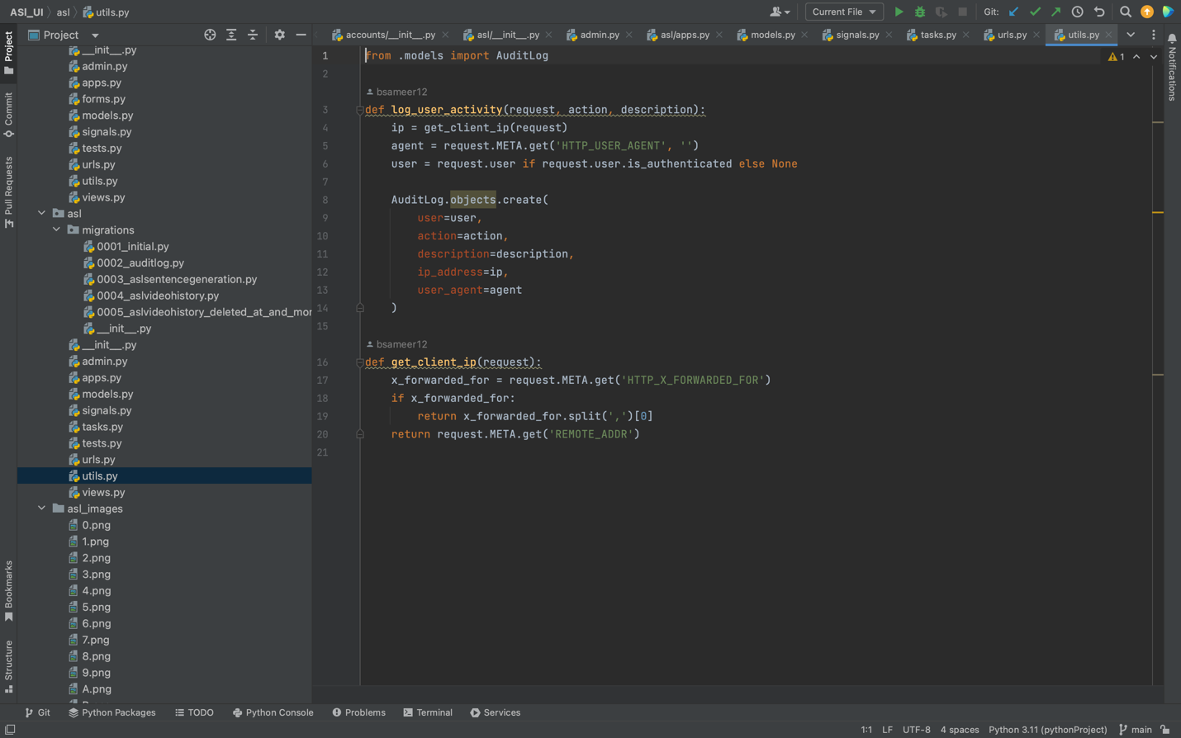

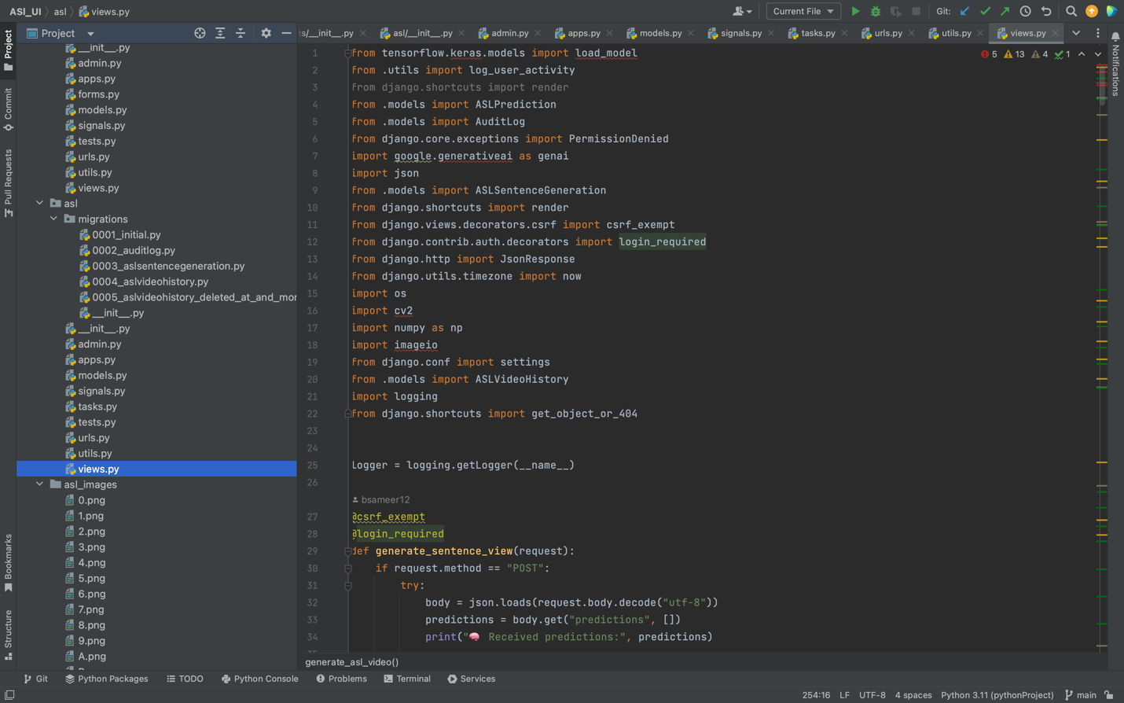

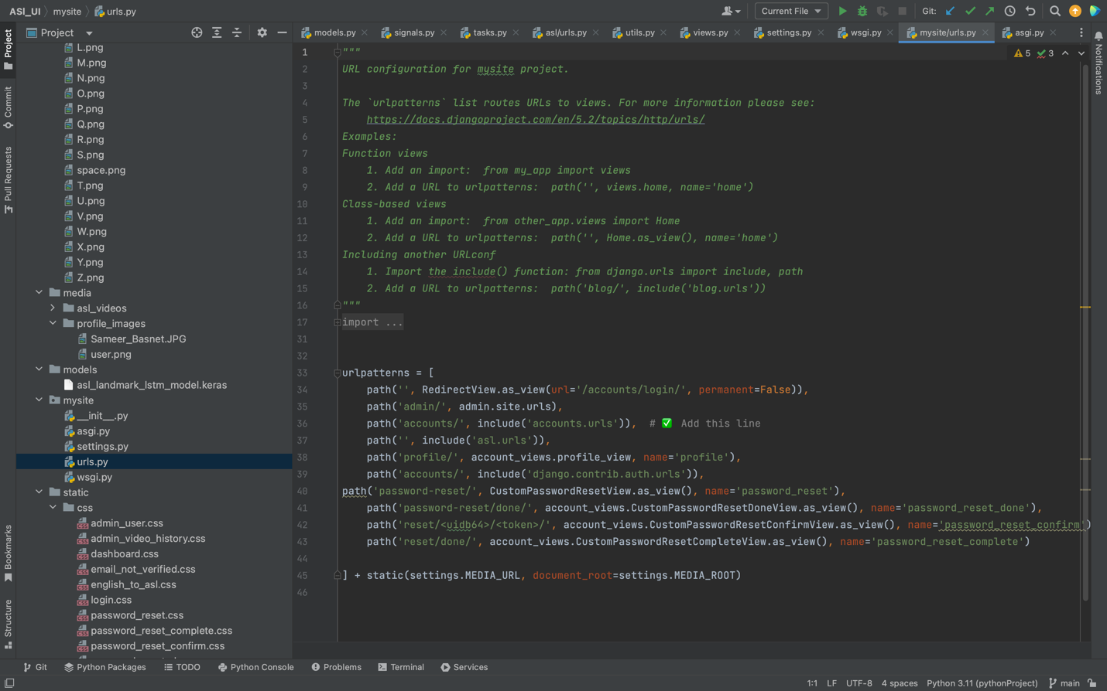

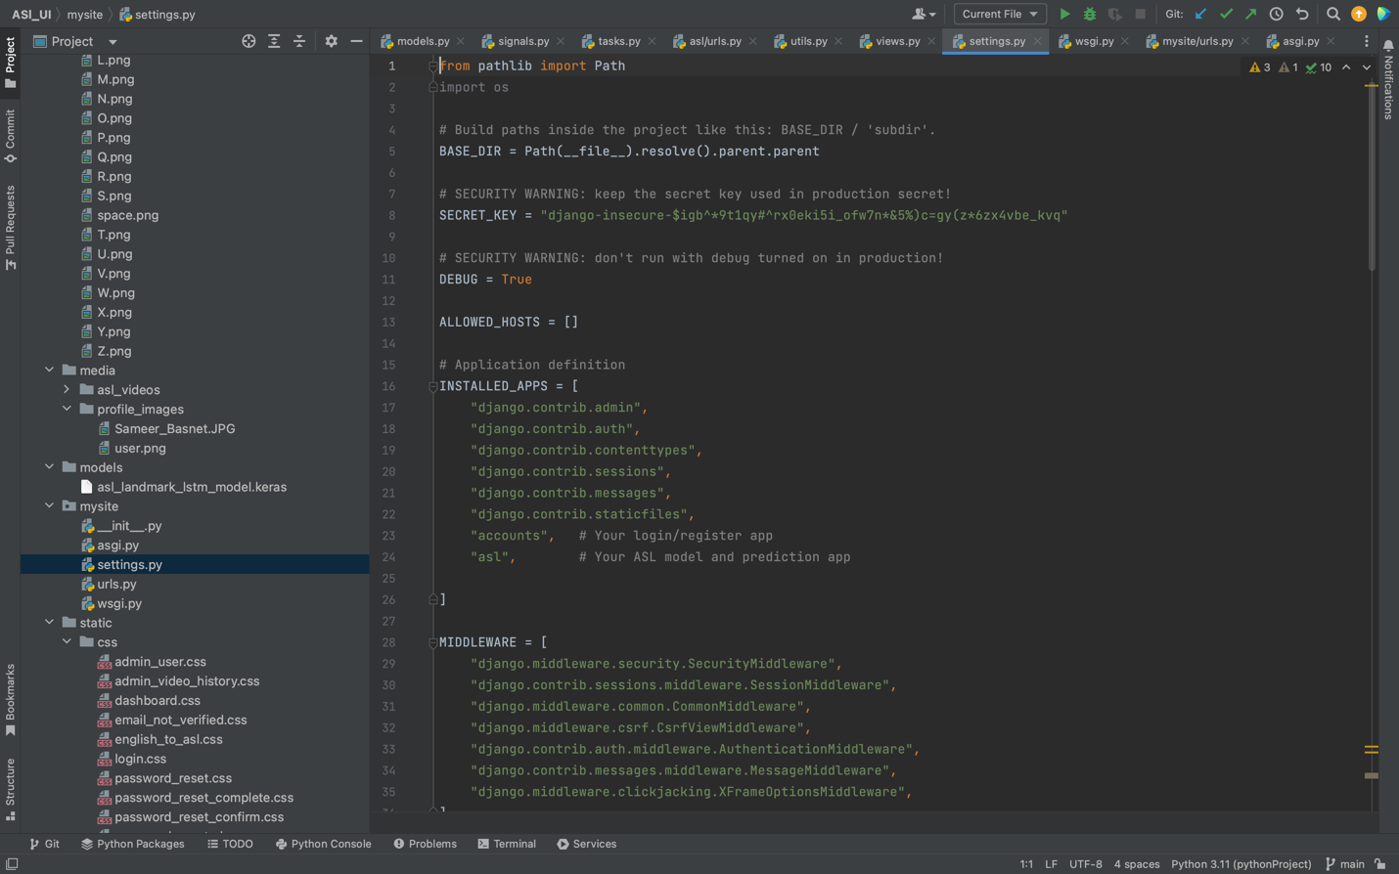

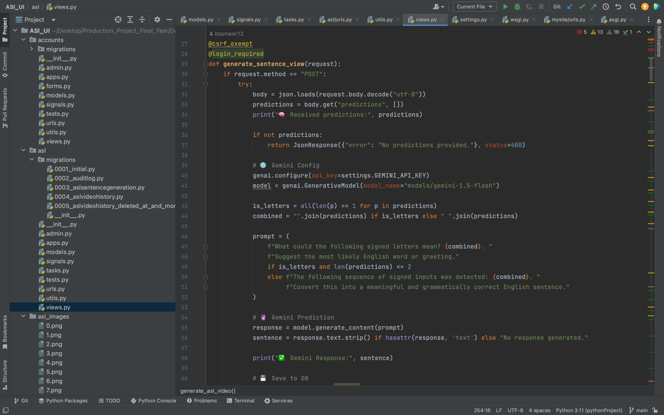

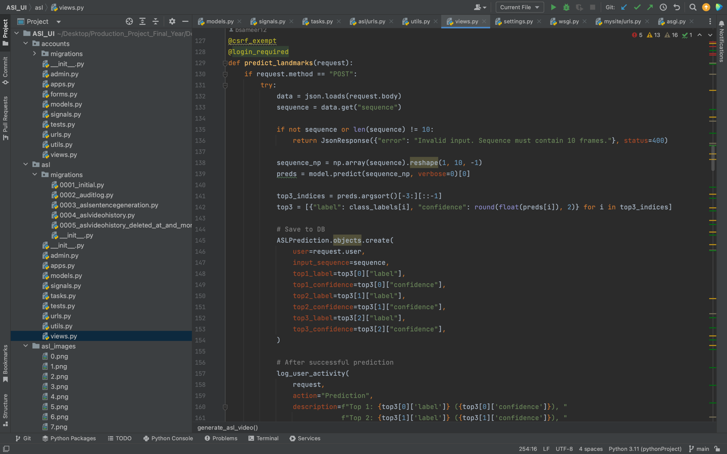

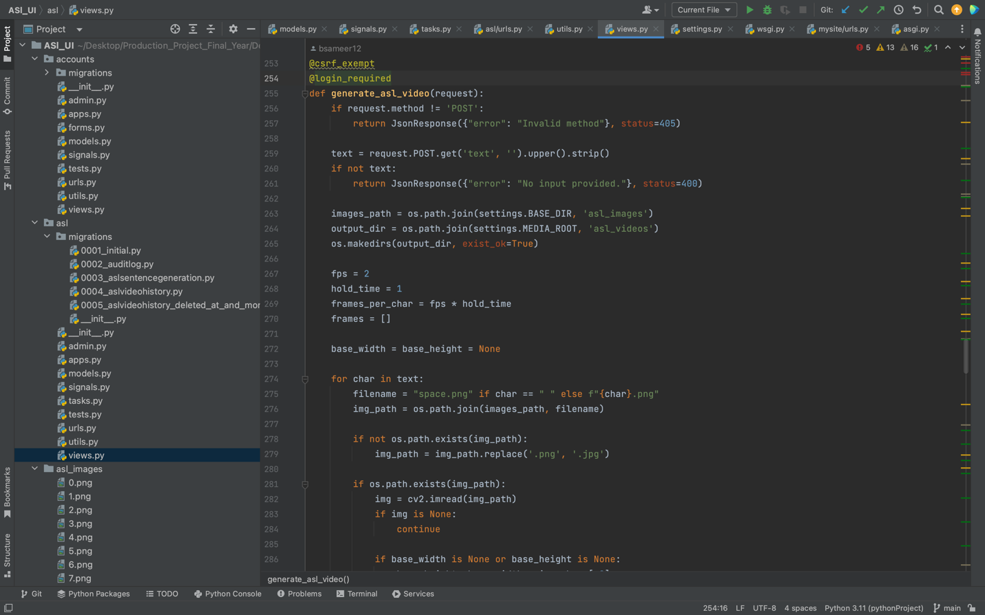

***11.4 Meeting Sheets Screenshots***

***11.5 Github Screenshots***

